|  |
| --- |
| Liverpool Hope University |
| Robotic dances to characterise heart conditions |
| **Daniel David McHugh**  **Student ID: 13005235** |
| **Computer Science** |
| **Liverpool Hope University**  **Research Supervisor: Dr. Thanapong Chaichana**  **Submitted to Liverpool Hope University, 24th April, 2017** |
|  |

****

|  |
| --- |
|  |

**Declaration**

I hereby declare that this is entirely my own work and that it has not been submitted as an exercise for the award of a degree at this or any other University. I agree that the Library may lend or copy this dissertation on request.

**Signature:**

**\_\_\_\_\_\_\_\_\_\_\_\_\_\_\_\_\_\_\_\_\_\_\_\_\_**

**Daniel D. McHugh**

April 2017

**Summary**

In this study, robots were used to see if they could create a movement based on an ECG pattern to do this certain software was used which would allow us to create the movement needed and create the ECG patterns that the robot could follow. This research is designed to test the power of robots and prove how adaptable they are in the medical field over the many years of research only a few robots have been able to work together with humans as researched in this paper this use of robots is not enough as robots could play a massive role in the near future.

**Acknowledgements**

I would like to thank everyone that has been involved in the making of this paper without your help this paper would never have been made so thank you very much and I wish you all the best. I would like to give special thanks to Dr. Mark Barrett-Baxendale, Dr. Thanapong Chaichana and Dr. David Reid for all their help with this project.

Contents

[List of Figures 6](#_Toc480771688)

[Abstract 8](#_Toc480771689)

[Introduction 8](#_Toc480771690)

[Aims and Objectives 9](#_Toc480771691)

[Related Work 10](#_Toc480771692)

[Method 14](#_Toc480771693)

[Multiple techniques of Recording ECG signals 14](#_Toc480771694)

[Detection and Analysis of normal ECG signal 15](#_Toc480771695)

[Detection and Analysis of irregular ECG signal 17](#_Toc480771696)

[Creation of Two-Dimensional Mapping ECG models for robot movements 19](#_Toc480771697)

[Classification Patterns of 2D ECG Modelling 20](#_Toc480771698)

[Simulation of Robot Programming over the 2D ECG patterns 20](#_Toc480771699)

[Results 23](#_Toc480771700)

[illustration of healthy 2D ECG patterns 23](#_Toc480771701)

[illustration of unhealthy 2D ECG patterns 25](#_Toc480771702)

[Simulation of Robot moving upon normal 2D ECG patterns 26](#_Toc480771703)

[Simulation of Robot moving upon abnormal 2D ECG patterns 30](#_Toc480771704)

[Analytical comparison of robot movement 35](#_Toc480771705)

[Conclusion and Ongoing Work 41](#_Toc480771706)

[References 42](#_Toc480771707)

[Appendix 44](#_Toc480771708)

## List of Figures

Figure 1. ECG electrode system…………………………………………………….... pg.15

Figure 2. Waves of the ECG………………………………………………………………...pg.16

Figure 3. How the heart creates a beat and the different heartbeats…………………...pg.16

Figure 4. Sinus Bradycardia…………………………………………………………………pg.18

Figure 5. Atrial Fibrillation…………………………………………………………… pg.18

Figure 6. 3D model of the robot in the R+ motion software…………………………...pg.22

Figure 7. How robot movement is created……………………………………………. pg.22

Figure 8. Saving the movement to the timeline………………………………………. pg.23

Figure 9. First healthy ECG result……………………………………………………. pg.23

Figure 10. Second healthy ECG result…………………………………………………pg.24

Figure 11. Third healthy ECG result…………………………………………………...pg.24

Figure 12. First Abnormal ECG result…………………………………………………pg.25

Figure 13. Second Abnormal ECG result………………………………………………pg.25

Figure 14. Third Abnormal ECG result………………………………………………...pg.26

Figure 15. Summary of 2D ECG pattern and 3D robot movement first healthy result………………………………………………………………………………pg.26-27

Figure 16. Summary of 2D ECG pattern and 3D robot movement second healthy result ………………………………………………………………………………………… pg.28

Figure 17. Summary of 2D ECG pattern and 3D robot movement third healthy result ………………………………………………………………………………………… pg.29

Figure 18. Summary of 2D ECG pattern and 3D robot movement first abnormal result ………………………………………………………………………………………….pg.30

Figure 19. Summary of 2D ECG pattern and 3D robot movement second abnormal result ………………………………………………………………………………………pg.31-32

Figure 20. Summary of 2D ECG pattern and 3D robot movement third abnormal result ………………………………………………………………………………………pg.33

Figure 21. Comparison of robot movement………………………………………...pg.35

Figure 22. Comparison of imaging patterns………………………………………...pg.38

**Keywords**: Robotics, ECG, Electrocardiogram, Heart disease, Humanoid interaction

## Abstract

Robotics is a step into the future which could enhance all our lives from robotic shop assistants to robotic nurses these are but a few projects that could become a very real possibility with time and effort. This research is one of the most exciting in the world as the amount of uses for robots is infinite because of these the field is always changing creating more advanced robots that can do more complex jobs making our life's easier. This paper proposes that a robot can dance to an ECG signal which will allow a person to correctly characterize the condition of the heart this will be shown by the movement of the robot depending on the movement will tell the person how healthy or abnormal the heart is.

## Introduction

Heart disease is one of the biggest risk factors in the modern day killing around 610,000 people which is in the USA alone this means that one in every four deaths is caused by heart disease the most common type of heart disease is coronary heart disease (CHD) which only killed over 370,000 people. This is not only a problem for the old but the young, as well as heart disease, can strike anyone at any age this is why in recent years the push for more research has been the focus at World Health Organization (WHO).

In our every changing world that continues to improve as time goes on people have designed and develop tools that allows us to see early signs of heart disease one of these tools is an Electrocardiogram (ECG) which reads electrical signals in the hearts then displays this signal as a pattern which then can be read to see if there are any blocks or issues with the heart this has saved many people and is a safe way to check how the heart is.

As new technology is created to better our lives people must adapt to the changes that this new technology brings one of the more recent changes in the medical field is the use of robotics in medical procedures many of the more dangerous procedures that require pinpoint accuracy are now done with a robotic arm which can provide the level of accuracy needed to lower the risk. The reason why I'm keen in this area is because robotics is a field that is becoming vastly popular another reason is that humans have yet to unlock the full use of robots in all fields which is why more robots should be implemented into today's society.

After this section, the aims of the study will be listed this will set out goals that this paper hopes to achieve after that other people's work will be analysed this will include a briefly talk about the paper and comparisons will be made to show how our research will impact the study. This will be followed by the method this is an in-depth talk about how the results were created then the results will be talked about this will explain what they mean and comparisons will be made to show the defences and finally the conclusion and ongoing work will be talked about this will explain how the study went and what are the possible works that can come from this study.

## Aims and Objectives

My aims for this paper is to build a robot that can read an ECG signal from a program then depending on what the signal outputs will respond with an action this could vary depending on how fast or slow the signal is. This study enforces the idea that robots within the healthcare are very important study in the medical field which has proven to create more accurate methods and to provide more accurate results which in some cases has given us a better understanding of the disease.

In order to achieve my aims for this paper the following objectives will be reached…

1. Research related topics to find materials to use for my purpose.
2. Collect material together and pick out the most useful material.
3. Search for a suitable robot and parts for that robot to fit my needs.
4. Build the robot.
5. Program the robot to understand signal inputs.
6. Get sample ECG readings to use for testing.
7. Test robot with software to see if it can detect and understand signal input.
8. Document results and report findings.

## Related Work

In the United States alone the total cost for heart disease is around $207 billion each year this includes the cost of health care, services and medication it is well known that heart disease is the leading cause of death for both men and women in the year 2014 coronary heart disease was the most common type of heart disease killing more than 365,000 people due to the rise of heart disease more research has to be done in order to stop or prevent the disease from happening (DailyCare BioMedical Inc., 2017).

Electrocardiogram (ECG) is the visible results from the hearts functionality using these readings the condition of the heart can be seen without performing any invasive methods (DailyCare BioMedical Inc., 2017). Using ECG results to tell us how the heart is can be the same as saving someone’s life from these results any issues with the heart can be quickly spotted (DailyCare BioMedical Inc). The problem with ECGs is how the signal is stored, transmitted and retrieved the issue faced is how can the signals be efficiently stored and transmitted these ECG signals in a digital form. This has become an every pressing issue that has become one of the most needed areas of development in recent years also another issue is how ECGs display there results as it can be hard to read the results if you have no experience with ECGs so creating a better way to display the results is an important field which can benefit everyone as it would lead to more accurate diagnosing.

Past research on ECGs study SaniM. Isa, Ary Noviyantoa, Wisnu Jatmikoa, Aniati Murni Arymurthy.2012. Has shown how the use of SPIHT and beat reordering as a way to compress and decompress ECG signal the method that was proposed gives low distortion at high compression rate but at the same time there is no significant effect of ECG signal compression to the accuracy of sleep stage classification using ECG signal.

AnasM.N. A.N. Norali, W.Jun. 2014. Shows the use of a different way to measure an ECG signal using a different algorithm called on-line which shows that it can monitor the signal and more importantly it provides faster results compared to the conventional methods used in clinical instrument this provides faster results which help diagnose the person. This research is very important to the field, as it not only creates a new method to measure ECG signals, which is faster than the clinical instrument.

While the above research provides a method of how ECG results can be stored and transmitted there will always be a need to expand our storage as the amount of ECG signals generated will always continue to grow so the development of new methods is very important.

More than now health care is very important and with people living longer lives the chance of illness has increased as well this is why technology needs to always improve so the level of care that can be provide can also increase but the problem is how do you make sure that each person gets the right amount of care one idea is hire more people to provide the care needed but this will only put a greater strain on the health care budget which could be used for more important things like new equipment. So, the method that is propose in this study is using more humanoid robots in our health care this will not only cut the amount of money the health care needs to spend to pay for people but it will also eliminate human error in the workplace which for many years has caused so many issues in the health care business.

The main problem with this is method is how will people react to a robot treating them in many cases that robots have been implemented in the work environment a lot of people are distrusting or uncomfortable with interacting with the robot as seen in (Zanchettin *et al*., 2013). The reason why people would be distrusting or uncomfortable with humanoid robots replacing nurses and doctors is that people have a self-created image of our health care that the care that is receive has to be "warm" and by replacing the people that care for us with robots that "warm" aspect that the health care has will be lost the health care robots can't give a person that "warm" care that many people expect to have. This is further backed up by the image people have of robots as they are seen as "cold" machines which to a point is true but as more development is made into the study these factors like “warmth” care can be achieved which is a requirement in health care.

Past research on robots in the work environment Andrea Maria Zanchettin, Luca Bascetta, Paolo Rocco. 2013. Informs us how the gap between humans and robots could be bridged this means that human and robot could work together in the near future one quote that really stands out is "Human-robot cooperation should not just be physically safe, But also psychologically comfortable to the humans"(De Santis *et al*., 2008). This has been one of the most problematic issues when implementing a robot into the working society as many people would rather work with another living being.

So, to resolve this the robot would have to be made more human-like but not too human there is a theory called the "uncanny valley" which applies to this situation which is as followed a phenomenon whereby a humanoid robot that is almost the same as a human arouses a sense of unease in the human. This phenomenon of talking and interacting with robots is a very real issue which stops the movement of all robots and humanoids working together with humans if this issue could be overcome the start of more social interaction could be possible with time this phenomenon will be erased and allow us to development more well-rounded humanoids.

In this paper Allison Saupp´e, and Bilge Mutlu. 2015. Talk about designing a pattern for human and robot interaction they first observed and analysed human interaction this formed the building blocks that would be used to build the interaction design which would allow them to prototype human-robot interaction. Five interaction scenarios which would test to see how interactive the robot and human are in certain environments using this they identified seven patterns that would be used to build human-robot interaction. Each interaction has its own aims and goals, which is a test to see how well the robot interacted with the human.

Another important research subject in this paper is the term "initial interaction" pattern proposed by (Kahn *et al*., 2008.). This talks about the first interaction between two humans so hello or hi this is a key point in any interaction as it lets two people know that the interaction has started but this line of research has no developed tools or environments to support designers.

So, this line of research has had no progress while other interaction research has this to me is a big loss in terms of interaction as if you just start talking to someone without the initial interaction how do they know that you are talking to them. This would create a gap in interaction, as one person would not know that they were interacting with another person this is similar with human and robot interaction as well how is the human to know about the interaction if there is no initial start.

Z. Zenn Bien, and Hyong-Euk Lee.2007. Explain the different models used to create HRI (Human-robot interaction) and the different characteristics of humans when interacting with each other it also highlights the often talked about subject of robots working with us in society with this in mind they push some key points out that have become the core fundamentals in HRI. One of these is the robot needs to be friendly as simple as it sounds when interacting with another person one of the key aspects of continued interaction is being friendly which to us is no problem but to a manmade machine it can be very hard to convey the same feeling as a lot of factors need to be taken into account one of these would be tone of voice similar issues are raised in (Zanchettin *et al*. 2013).

It carries on to talk about how the use of FSL (Fuzzy set and logic) learning techniques and soft computing toolbox to effectively model human behaviour patterns as well it can be used to process human bio-signals. Which include facial expressions, hand/body gestures and ECG signals not only this but soft computing toolbox is used for human intention as well as human physical status and behaviour they then used two projects to briefly show that FSL and soft computing toolbox can be successfully applied for HRI.

Sven Wehner, and Maren Bennewitz. 2014. Talk about creating a new walk pattern for a humanoid robot with a more human-like walk as many of the humanoid robots being made walk unnaturally not only will this help the robot as it will be more stable but it will help it blend in when interacting with humans. To do this the researchers talk about how they developed four algorithms that work with the joints to create a more human-like walk not only that but they are using a full body motion capture suit that is used to gather data about how a normal walk should be like.

This is very important research as the end goal is to make robots and humans work closely together this type of research needs to be more researched as more time invested into the development of humanoid robots. As humans, the need to start thinking about how to integrate these robots into our society is a must this study is a good start as if more robots become like us people will start getting used to the idea of robots in our lives helping us with tasks.

To conclude the related works these studies are very good as they explain the stage of integration between humans and robots and it shows us how a realistic robot could be possible that would be great in modern day commercialism, as it would speed up business transactions. But as shown in other studies feel like the chances of seeing a humanoid robot working and serving customers in a shop will not happen anytime soon as many people will not like the idea that a robot is serving them as people like to interact with another person which would be impossible if a robot was there.

## Method

### Multiple techniques of Recording ECG signals

ECGs have been used in the medical field for many years now and have given us precise information about how our hearts are but what are the techniques that are used to actual show us an ECG signal in this part of the report the different techniques used will be explained.

One of the most common techniques which is used most of the time involves the use of two pieces of equipment the first one is an electrode which is a pad that is placed on the person there are a total of ten these pads are placed in certain locations on the body you can see the location of these electrodes in Figure one. These pads, when applied to a person, will receive an electrical signal from the body normally this would be a movement not only does an electrode pick up an electric signal it transports these signals to the ECG machine.

The other piece of equipment that is used is called a lead this is not a real lead but an imaginary line which is used to record the electrical activity of two electrodes for example if the doctor wanted to find out the calculation between the left arm and the right arm he would use lead I. Two electrodes make one lead there can be up to twelve different lead combinations some of these are Lead II, Lead III, aVR and aVF these use the different electrodes on the body and show us different patterns.

Below are the leads and the electrodes that relate to that lead...

* Lead I – Lateral view(RA-LA)
* Lead II – Inferior view(RA-LL)
* Lead III – Inferior view(LA-LL)
* aVR – Lateral view(LA+LL/RA)
* aVL – Lateral view(RA+LL/LA)
* aVF – Inferior view(RA+LA/LL)

In the example above a twelve lead ECG is used, this is the most common out of all the ECG lead machines and it produces good enough results to be used all the time. Now the reason why it is called a twelve-lead ECG is because there are twelve leads in total on this machine which also means that it will print out twelve different results the same be said about the other ECG machines, for example, a 3 lead ECG will only have three leads in total and can only print out three results.

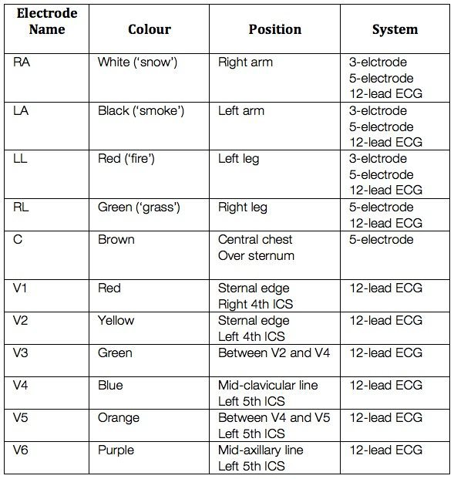

Fig 1. Shows the names and the placement of the electrodes as you can see each have their own colour to identify them also you can see which ones are used on what ECG machine. (Cadogan M.).

### Detection and Analysis of normal ECG signal

Now that electrodes have been talked about next is how an ECG signal can help us to detect and analyse the condition of the heart. To do this the first ECG pattern needs to be compared to the next set but you can't just get two patterns and stick them side by side the waves need to be closely analysed to see if they are any differences. (See Figure 2 for a diagram of the different waves), (See Figure 3 for a more in-depth wave format).

So, what needs to be done is split the pattern into different sections the first wave is called the P wave this is when the right and left atria depolarize this wave is normally slightly rounded and not as tall as the other waves. After that is the QRS complex this has three different deflections the first one being Q if the signal drops into the negative it is called a wave in a normal ECG this is to be expected a small Q wave but it does depend on the ECG leads you are using. Next, is the R deflection this is the second upward deflection in the ECG the R wave is the easiest wave to spot out of all the others as in a normal ECG this is the highest reading that will occur on the ECG also the R value represents early ventricular depolarization.

Depending on how the R wave is formed can give us clues about a certain disease for example if the R wave is reduced in size it could be a sign of obesity the last of the three deflections is the S wave it is the first negative wave after the R wave it represents the late ventricular depolarization. The last wave in a single ECG pattern is the T wave it represents the repolarisation of the ventricles this wave brings the S wave out of the negative and restarts the whole pattern again when this value is normal the wave should be slightly rounded and slightly asymmetric. (See Figure 2 for different ECG patterns and how the heart creates a beat).

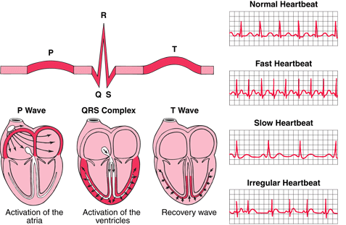

Fig 2. Shows what the different waves on an ECG look like also it shows what happens at the different stages in the ECG to create a heartbeat alongside this you can see some examples of heartbeats which will be compared to see how they differ. (Cadogan, M.).

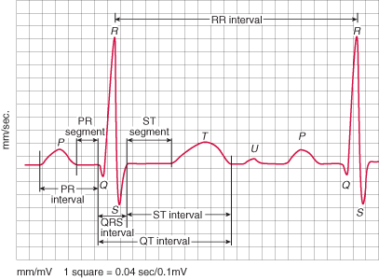

Fig 3. Shows how to use the different waves to perform calculations to find information about the heart as you can see in the diagram there are two types of calculations Segment and Interval. The main difference between the two is that interval always starts at the start of the wave and ends at the start of the other waves so an example of this would be the PR interval will start at the P wave and end at the start of the QRS complex. As for Segment, it would start at the end of the current wave and end at the start of the next wave so take the PR Segment as an example it would start at the end of the P wave and end at the start of the QRS complex. (Gould, A. 2011).

### Detection and Analysis of irregular ECG signal

Now that the healthy ECG signals have been discussed the next section is what an irregular ECG looks like the different waves values in the ECG will help us identify what is wrong with the heartbeat and what action should the doctor take to fix the problem.

So as before spilt the ECG into the different waves these are as followed P wave, QRS complex, T wave and finally the S wave but unlike before the irregular point will be made clear this will allow better understanding of irregular characteristics in the different waves. As always the P wave is first as stated before the wave should be slightly around if not this could be a sign of an irregular heartbeat the shape is very important in an ECG as it can tell us if the heart has a blockage, if one of the sides is not working correctly or if one side is overworked to keep up with the bodies demand. An example of this is Aortic valve stenosis this is a congenital heart disease (CHD) where the main artery the aortic is narrowed meaning that the left ventricle becomes much thicker as it has to work much harder to pump blood to the rest of the body.

Another characteristic that you should look for is the duration of the wave in a normal wave this should be less than one hundred and twenty milliseconds (ms) if the duration is too long it could mean that the atrial is having some problems depolarising this is one example but it could be a sign of many CHD.

Another important characteristic that you have look for is the Axis this is the pitch of the wave in a normal ECG the axis should be between zero and seventy-five this is linked with shape as if the shape of the wave is off then normally the axis is as well this could relate to one of the atriums being larger than normal this would explain why you might have a peak when looking at the P value. In addition, an important note to add is that the P wave should always be in the positive never the negative in some cases the P-wave has not been detected in a normal ECG this does not mean that the heart has some issue it could mean that the electric impulse is low so the electrode can't pick it up.

Next is the QRS complex as stated before this is a series of three deflections the first one is the Q wave then R wave and finally the S wave these are always together in a normal QRS the duration should be between seventy and one hundred and ten ms. So, trying to spot an irregular characteristic can be difficult the easiest one to spot is the R wave as it is the highest reading in the whole ECG it should always be positive if the reading has gone into the negatives then this should tell you that the QRS complex is irregular.

When talking about QRS in relation to being irregular there is one common complex that is talked about which is called Broad complexes, which is, when the QRS signal is over one hundred ms, which is classed as abnormal. If the duration is more than one hundred and twenty then it is required to be diagnosed which could lead to finding some of these diseases bundle branch block, Hyperkalaemia, Hypothermia and ventricular pacing.

Finally, the T wave this is not as important as the other waves because some ECG machines do not use the T wave to form a complete pattern but it is important to know if the T-wave is not normal. Some of the characteristics of the T waves is that when the QRS complex ends the T waves is the positive deflection this means that if you get a negative reading right after the S wave then you know that the T wave might be irregular.

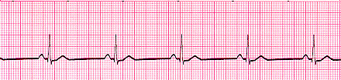Some of the known T wave abnormalities are Hyperacute, Inverted, Biphasic, Camel Hump and Flattened each of these have traits that allow you spot them for example in Biphasic you can see two very different T waves one of them will go up then down and the other one will go down then up these are caused by two diseases. The first one is myocardial ischaemia, which makes the T wave go up then down, and the second one is Hypokalaemic, which makes the T wave go down then up as you can see these two are very similar so it is easy to get them mixed up. (See Figure 5 to see an irregular ECG).

Fig 4. Shows a normal ECG signal this pattern is called Sinus Bradycardia Rhythm the reason why this is called a Sinus Bradycardia Rhythm is because the P wave can be clearly seen this also shows that depolarization of the cardiac muscle begins at the Sinus node or the SA node. (NixonMcInnes, 2013).

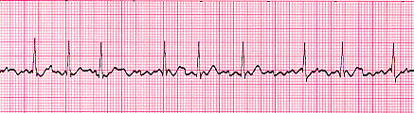

Fig 5. Shows an irregular ECG signal this pattern is called Atrial Fibrillation as the atrial generates its own electrical impulse this can lead to irregular conduction of impulses to the ventricles, which creates a heartbeat. Although it may cause no symptoms that are critical to the body it is worth noting, that Atrial Fibrillation is often associated with palpitation, fainting and chest pains. (NixonMcInnes, 2013).

### Creation of Two-Dimensional Mapping ECG models for robot movements

In the last section, the Detection and Analysis of ECGs were discussed now that it has finished the next part will explain how to convert a 1D (one dimensional) ECG to a 2D (two-dimensional) ECG there are many reasons to do this. In our case the reason why is because when it comes to matching the ECG pattern with the robot movements it would be inaccurate to use the 1D ECG so to make the robot and the ECG pattern more synchronized the use of the 2D ECG will be needed. Not only will the robot be more synchronized but the results that have been collected will be more refined meaning that the results that will be collected will be more accurate and more useful to us.

Now that the reason why the 1D ECG can't be used and the need to convert it to a 2D ECG has been explained it is time to talk about how to create the 2D ECG that will help the movements of the robot. What is needed first is to get our 1D ECG this can be a healthy ECG or an unhealthy ECG next is to convert it to a 2D ECG to do this certain software will need to use be used to create our ECGs the software that will be used is called MATLAB this allows us to create figures from data that will be inputted this software is well known in the science field as it has a lot of functionality that allows users to create all sorts of figures.

Before the data is added there are certain steps that need to be done the first step is save the project this sets up the directory so when the project gets saved it knows where to save it all after that the project needs to be cleaned to do this certain commands have to be entered which are as followed CLC, Clear All and Close All these commands will completely remove any data that is in the program this will allow us to begin a new project.

Next is the data that will be added to do this a variable name needs to be assigned an example could be "signal1d" when the name has been assigned the data can be added to do this the equals sign needs to be inserted followed by square brackets between these brackets is the data. An example of the would be "2,4,10,11" and so on until you have entered all the data also one important point is every line has to end in a semi-colon this tells the program that this command has ended and a new one will begin.

And the last step is to create the figure itself to do like before a name must be given for example "figure (1)" the name figure is the name that will be assigned and the number will tell us what order that figure will be placed in now that the name is created and the order of the figure has been set. The next step is to display the figure this is done by adding the command "plot" with the data that is going to be displayed after that the run button will need to be pressed this will show us the data in ECG form from that converting it in a 2D ECG is simply.

### Classification Patterns of 2D ECG Modelling

Now that all the ECGs have been converted into 2D ECGs it’s time to split them up into two different classifications this is when you spilt them into groups based on certain traits that each ECG has for example in our case the ECGs will be split into two groups these are healthy and unhealthy. This step would normally be done while you are collecting your data as it allows you to know how much data you have but it can be done at any stage as all you are doing is collecting the results and splitting them up.

There are many different ways to classify ECGs the first is what has been done by us using the whole ECG pattern others ways could be by certain waves so you could split them into regular QRS and irregular QRS or you could be more specify and spilt them into single wave reading so an example would be all the P waves that are irregular could be compared to all the healthy ones. As you can tell classification allows us to pick out certain data that is needed so it can be compared to another set of results this allows us to refine our results making the comparison more critical.

The main reason the ECG is convert to 2D is to classify them this allows us to group them together as said before not only does this help us with identification of the ECGs but it also allows us to compare between the groups more easily as it’s better to say that figure one when compared to figure two is different because of this, this is a better way to show other people data as it allows them to easily see the differences between the two data.

### Simulation of Robot Programming over the 2D ECG patterns

Now that the ECGs have been converted and they have been classified it’s time to start working with the robot that has been built to do this certain software needs to be used as was stated before the first software is called R+ Motion this allows us to control the robot's servos which allow it to move this will be the primary software that will be used as it controls the robot's movement. Using the R+ Motion is simply all you need to do is add the robot as a Bluetooth device to the computer from this access the device on the computer this will give you some information about the robot but what is important to us is the COM number that has been assigned to the robot as this will allow us to connect to the robot using the software. (figure six shows the R+ Motion program).

After you have found out the COM number load up R+ Motion then select the robot you have in our case the Darwin-MINI will be selected after you have picked your robot a 3D model of that robot will appear. Next is to connect to the software to do this click on connect button which is located on the bottom left of the screen or press f10 then click on the sync mode button this will sync with the robot so when you move the 3D model on screen it will move the real robot.

Now that the robot is connected the next step is to create the movement but before that there is some terms that will need to be covered as this allow better understanding of the software so the first term that will be explained is Motion Unit this is what a single motion is called this is the very start of the movement to create a single motion unit just click on the list of motions then click on the plus button and name the motion this will then create and add to the list. Next is Motion list this is a group of motion units that are combined to create a series of movements to create a new motion list the same needs to be done just like before create a new motion list by pressing the plus button then name it after that you can add motion units to the list and it will create a series of movements. (figure seven shows the 3D model movements)

Also, you can change the parameters of the list, for example, you can edit the speed so the movement could be slow at first then later on speed up or the speed could be set to be the same all the way through. Another option you have is the amount of times it should loop through the default is set to one but you could loop a certain unit three times or more. And the last term is Motion Group this is where all the motion lists are added to one group this will then be downloaded to the robot so when accessed through the app the robot will be able to do the movements that have been created.

To add motion lists to a group all that is needed is create a new group like with the others name it and then simply click on the motion list and click on the add button this will add it to the group from this you can download it to the robot.

Now that the terms have been explained the next part will talk about how to move the robot to do this just select the servos needed then click on positioning this will bring up a dial use this to move the robot into any position then click anywhere on the timeline after that all you need to do is click the add button this will add the movement that was just created. So, when that motion is played it will go through all the movements in that motion. (figure eight will show this two added movements)

So now that the movement has been explained it's time to get our results from the ECGs and mirror the pattern to the robot this will be easy as the robot movements have been explained so all that is needed now is to create movement based on the ECG for example if the ECG is healthy then the robot's movements will be quick and active this will be saved in multiple motion units then put together in a motion list.

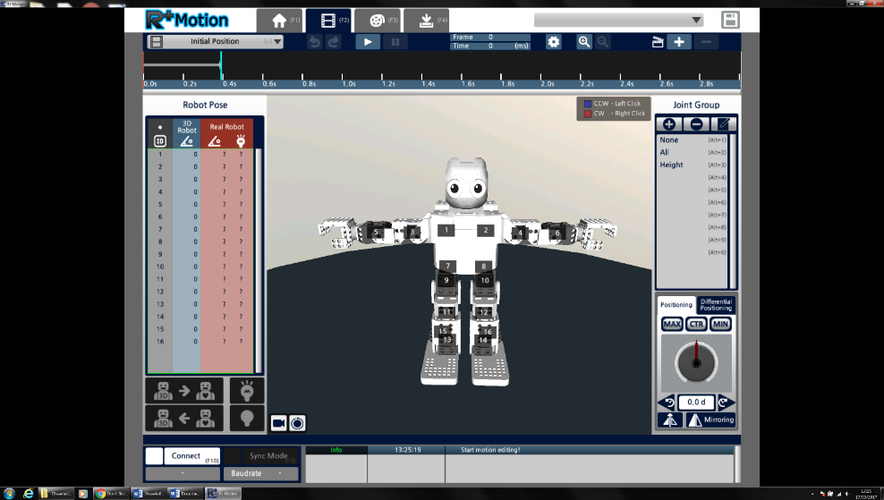While if an unhealthy ECG it created, it will be slow and lazy just like with the healthy ECG each movement will be saved in multiple motions and put together in one list then both of these lists will be placed inside a group then downloaded to the robot this will allow us to access them using the app. Using these different movements will allow us to show the difference in the ECGs as one will be very active while the other will be very slow and lazy.

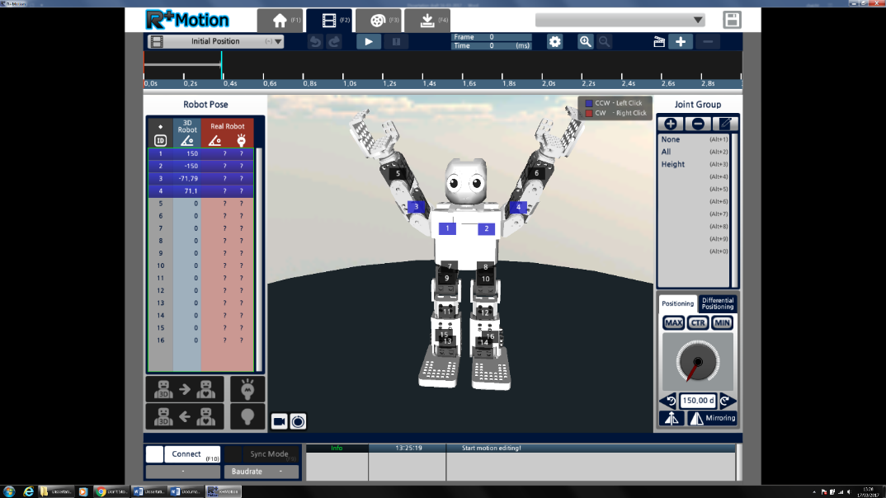Fig 6. In this figure the R+ motion is displaying the 3D model of the robot using this software allows us to create movement or play pre-set movements.

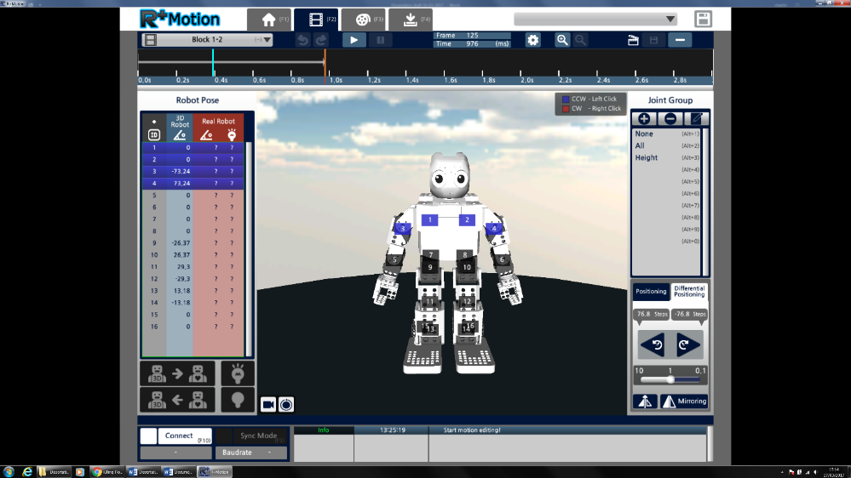Fig 7. In figure seven the robot has been moved by selecting the servos in the example above numbers 1, 2, 3 and 4 have been selected as you can see by moving these the robot has changed position.

Fig 8. In figure eight the movement has been added as shown by the timeline on top of the screen as you can see one blue line has been added this means that some movement has been saved and added to the timeline. Also, you can see that another action is about to be added to the orange line over another point on the timeline.

## Results

### illustration of healthy 2D ECG patterns

In this first section of the results, the healthy ECGs will be shown this data will be represented in both 2D and 3D format then a short explanation of the figure will be present to give information about the data. The software that is used to create these ECGs is called MatLab just to note that the 3D ECGs are just a plot feature on MatLab which gives the illusion of 3D.

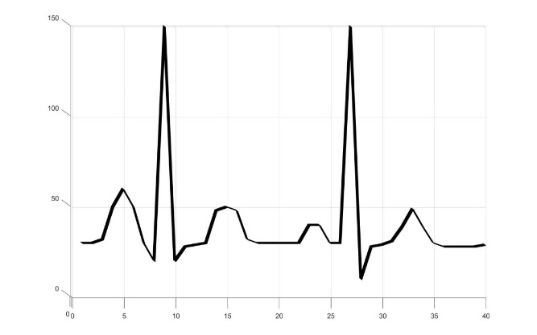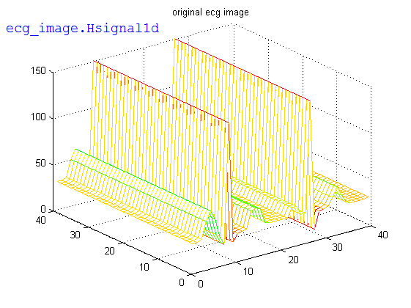

Fig 9. This is the first healthy ECG that was created this ECG pattern is called Normal Sinus Rhythm as you can see this pattern is good the reason why is you can clearly see all the different waves in the pattern also the shape of the waves is great you can easily define when one wave ends and another begins. By looking at this pattern certain information is known the first being that the rhythm is normal, second the QRS duration is normal, third is that the heart rate is between 60 – 99 BPM and finally the P waves are always visible before a QRS complex.

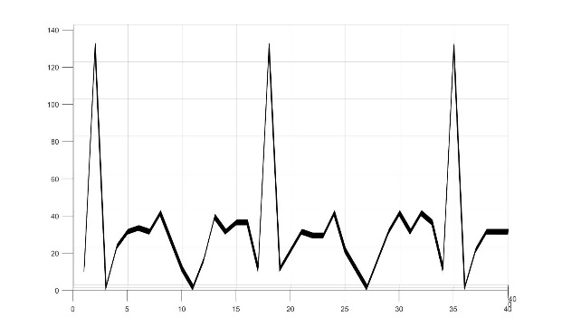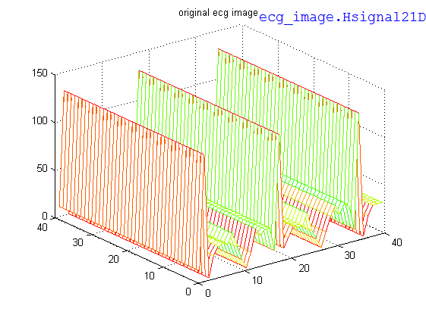

Fig 10. This is the second healthy ECG pattern this pattern is called Supraventricular Tachycardia (SVT) this is when the impulses stimulation the heart are not generated by the SA node but by the tissue around it. In this figure, the ECG would be classed as healthy as the rhythm and QRS are normal but the heart rate is high compared to a normal rate as the rate in this figure is 140 -220 BPM which is high.

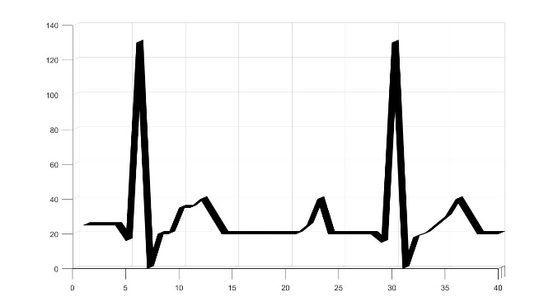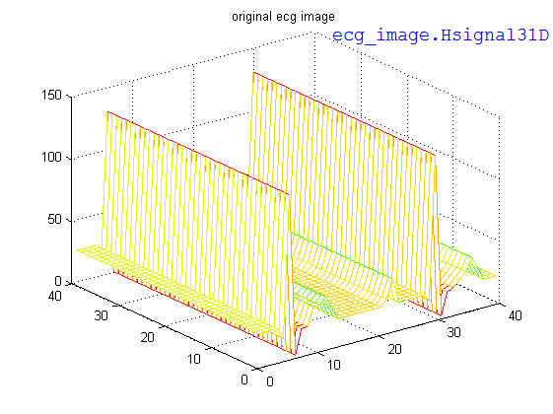

Fig 11. This is the third healthy ECG pattern this pattern is called 1st Degree AV Block this is when there is an electrical delay in the AV node to the ventricles this is not a problem by itself as the impulse does reach the ventricles thus causing no damage to the heart, in fact, this condition is often seen in trained athletes. As you can see in figure eleven the waves are still defined meaning that the heart is in good condition and the heart rate is 60-100 BPM also the rhythm is normal.

### illustration of unhealthy 2D ECG patterns

In this second section of the results, the unhealthy/Abnormal ECGs will be shown this data will be represented in both 2D and 3D format then a short explanation of the figure will be present to give information about the data. The software that is used to create these ECGs is called MatLab just to note that the 3D ECGs are just a plot feature on MatLab which gives the illusion of 3D.

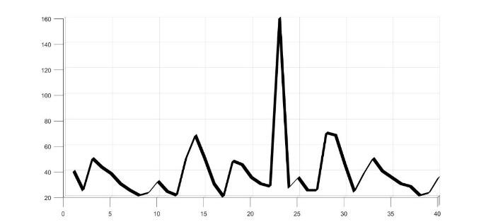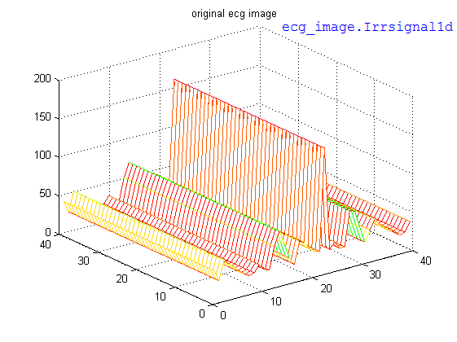

Fig 12. This the first unhealthy/Abnormal ECG pattern this is called Atrial Flutter as with SVT abnormal tissue is generating the rapid heart rate but in this case, the AV node is not involved in this case. From figure twelve you can see that the rhythm is off the second part of the pattern is fine but the first half is not this is shown by the R-value barely being present also you can see that waves aren't formed correctly this is another sign that this ECG is unhealthy/Abnormal another information to add is that the heart rate is around 110 BPM.

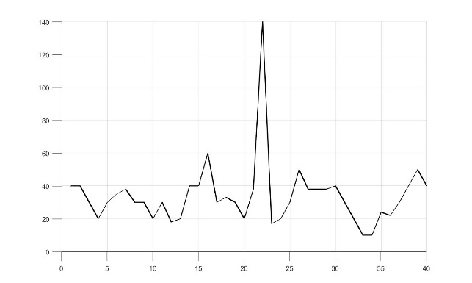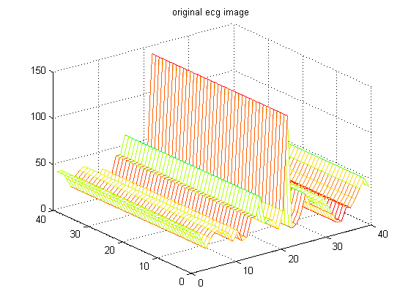

Fig 13. This is the second unhealthy/Abnormal ECG pattern this is called Atrial fibrillation this when many places within the atria are generating their own impulse this causes an irregular conduction of impulses to the ventricles which creates the heartbeat this can be felt by hand when taking a pulse. This may cause no problem but it is often related to palpitation, fainting, chest pains and most importantly congestive heart failure.

As seen in figure thirteen the rhythm is complete off given the characteristics of this disease this comes to no surprise as Atrial fibrillation is known for having irregular rhythms also the heart rate is high as well usually the rate is around 100 – 160 BPM this can be slowed by medication if needed another important feature is that the P-wave is not defined this is because the atria is firing off so many impulses that the ECG machine can't pick out the right impulse.

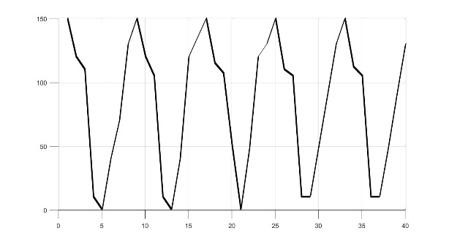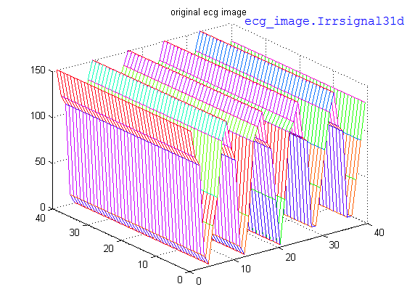

Fig 14. This the third unhealthy/Abnormal ECG pattern this is called Ventricular Tachycardia (VT) this is when abnormal tissues in the ventricles are generating a rapid and irregular heart rhythm if the person has poor cardiac output this pattern is normally related to them as this pattern is seen in many cardiac arrest cases. As seen in the above figure the QRS duration is prolonged and the P wave is not seen also the heart rate is around 180 – 190 BPM.

### Simulation of Robot moving upon normal 2D ECG patterns

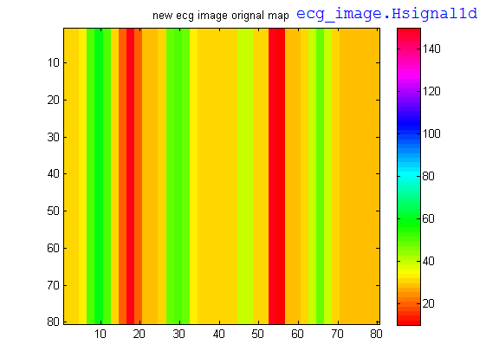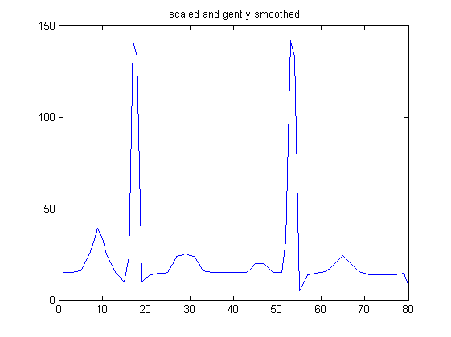

(B)

(A)

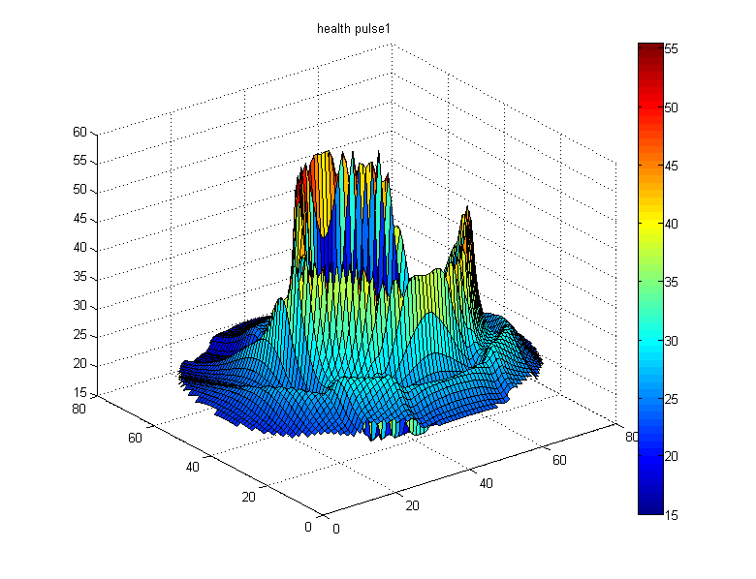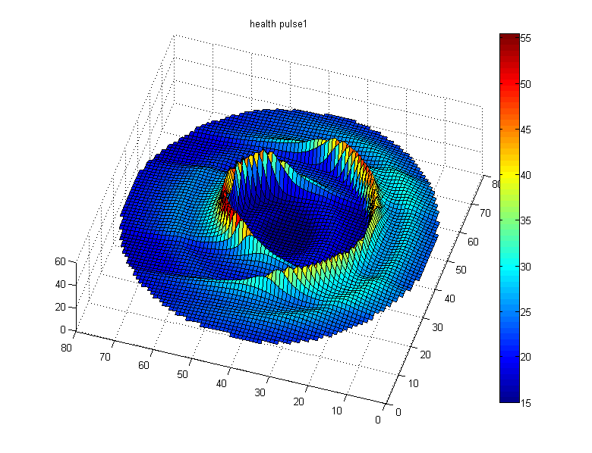

(D)

(C)

Fig 15. A normal pulse of ECG rhythm (A), ECG image of regular rhythm (B), and circular ECG map created based on ECG image in top-view (C) and front-view (D).

Now that the ECGs have been created it is time to use them with the robot and record how they movements as you can see from the group of figures above the 1D ECG (figure 15A) that has been scaled and smoothed from this figure 15B was created which is the 2D ECG and figure 15C and D are the circular maps that were created from using both A and B.

Figure B shows us what the heart is like using colours codes as you can see deep red is the highest amplitude that you can get and a lighter red is the lowest you can get using this key allows us to better understand the heart condition as seeing a lot of dark blues, purples and light blue tells us that the heart rate is high while dark green, light green and yellow show that the rate is low.

Using figures 15A and B allows us to create the circular map Figure 15C which gives us a better understanding of how high the amplitude is unlike the other two results the colour coding is a bit different as you can see a deep blue is the lowest amplitude you can get while on the others is was a light red also the get the highest peak the circular map was normalised as half of the 2d ECG.

Now that the other figures have been explained it's time to talk about figure 15D which is the robot's movement to this ECG as you can see it's presented like the other figure in a circular map this is because it allows us to better understand the movements of the robot in relation to the current ECG. So, in this example as there are a lot more medium to low amplitudes in the ECG the expected outcome is to have a lot of dark blues, light blues and greens compared to red and yellows which are high amplitudes as you can see from figure 15D of the robot's movement this is the case as a lot of low to medium amplitude compared to high amplitude just like the ECG.

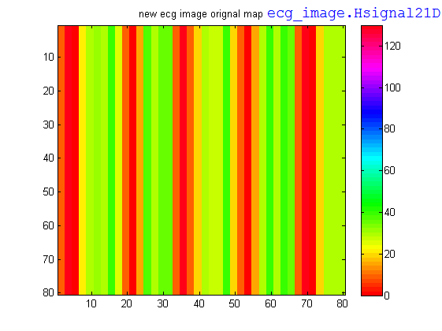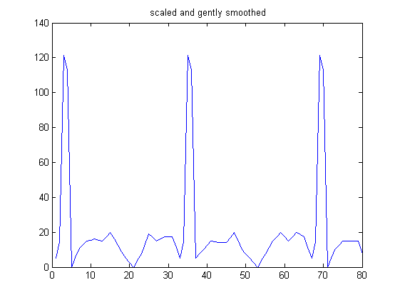

(B)

(A)

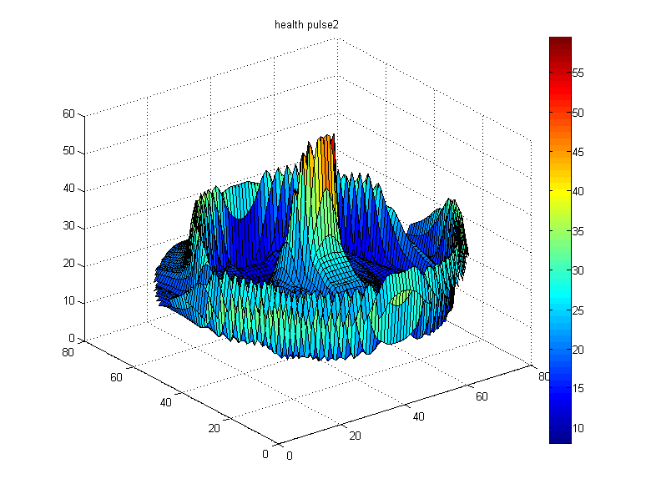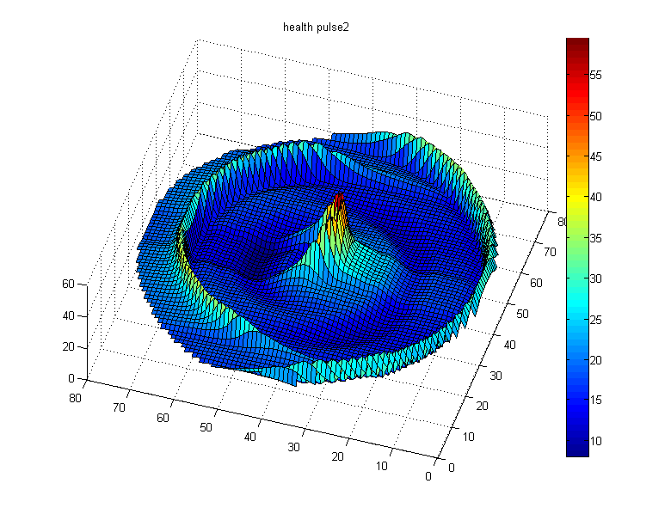

(D)

(C)

Fig 16. A normal pulse of ECG rhythm (A), ECG image of regular rhythm (B), and circular ECG map created based on ECG image in top-view (C) and front-view (D).

This is the second set of result from the healthy section as done before the 1D ECG (figure 16A) is the start point to creating all the other figures so like before each figure will be explained so that our results make sense. Figure 16B is the 2D ECG map with a clearly stated colour key this shows how healthy the heart is so in this example the heart is ok condition the reason why is because there is a lot of high amplitude shown by the deep red but what can be said is that the high amplitude seems to be in a set pattern this is good as if the high amplitude was in random positions it points to the heart being arrhythmia which means that the heart is off beat which would tell us if the heart has some issues.

From figure 16B it’s time to move on to the next figure which is figure16C this is the 2D ECG in a circular mapping unlike with the colour mapping this allows us to better see the amplitude as you can see the differences between low and high amplitude. Figure 16C shows that the waves have been split into two different waves the first wave which contains a lot of medium amplitude and small amounts of medium-high amplitude this is shown by the amount of light blue and green that form the wave. The inner wave contains more high amplitude this is shown by the amount of yellow and red that forms the wave the reason why there could be two different waves is because of how the signal is on the ECG so as a lot of the signal takes place in the lower sections on the ECG this could explain why the first wave has a lot of medium amplitude then the ECG signal suddenly spikes up which could explain why the inner spike is much taller.

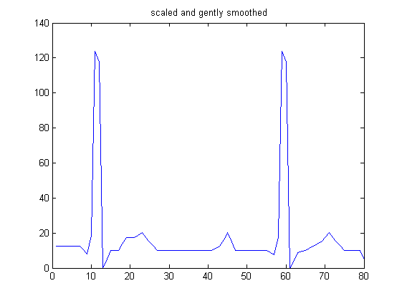Figure 16D is the robot’s movement this shows the robots dance pattern in relation to the ECG as you can see there is a lot of light blue this shows us that low amplitude movement was created also as you can the inner spike has a lot higher amplitude this shows us that high levels of amplitude were created. And the way the waves are formed tell us that the movement was steady not too fast or too slow this is shown by the size of these waves as if they were more red spikes this would mean that more fast movement took place.

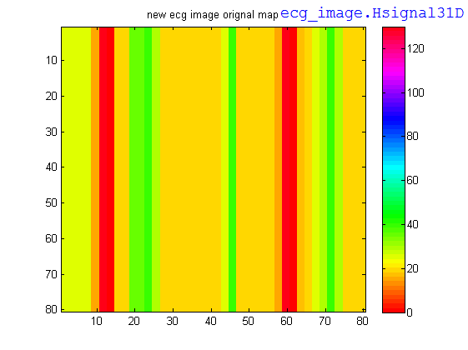

(B)

(A)

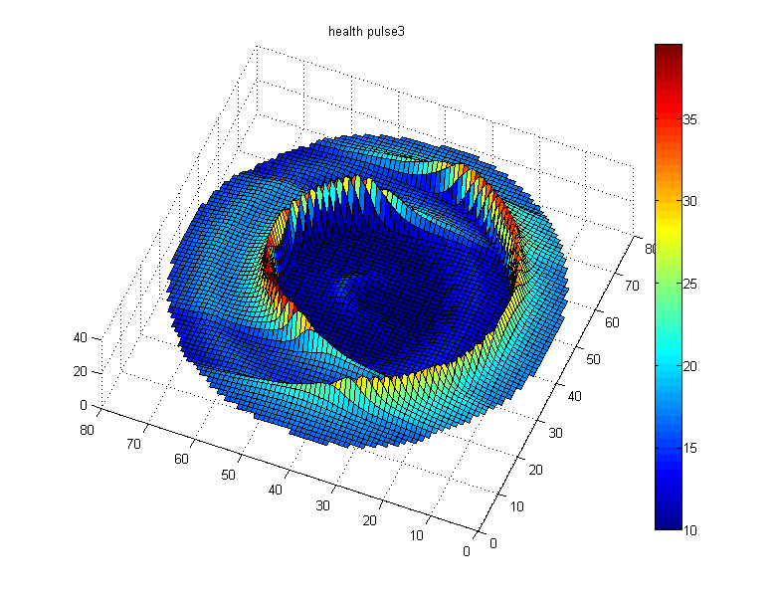

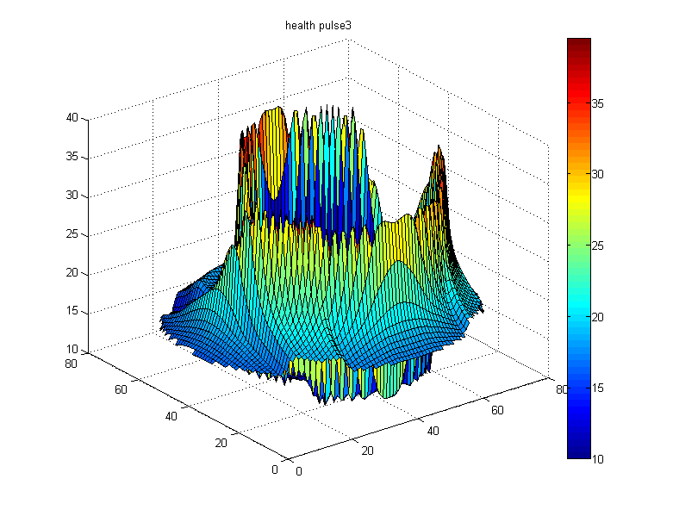

(C)

(D)

Fig 17. A normal pulse of ECG rhythm (A), ECG image of regular rhythm (B), and circular ECG map created based on ECG image in top-view (C) and front-view (D).

This is the third set of result from the healthy section as done before the 1D ECG (figure 17A) is the start point to creating all the other figures so like before each figure will be explained so that our results make sense. Figure 17B is the 2D ECG map with a clearly stated colour key this shows how healthy the heart is so in this example the heart is in good condition not many high amplitudes which is good and they seem to be in a set pattern like before. Which is good as it tells us that the heart rhythm is fine but unlike before this ECG seems to have a lot of medium to high amplitude this could be a problem later on but for now this is fine it just alerts us to the possible issues that could affect the person later on.

From figure 17B it’s time to move on to figure 17C this is the 2D ECG in a circular mapping unlike with the colour mapping this allows us to better see the amplitude as you can see the differences between low and high amplitude. In figure 17C you can see that the waves are very wide unlike other readings were there is a single point of spike in this result you can see that there are many points that are spiked this creates a more even ECG reading also to note that the spikes aren't covered in deep red which would tell us that very high amplitude is present you can see a lot of yellow at the bottom right part of the ECG.

Figure 17D is the robots movement this shows the robots dance pattern in relation to the ECG as you can see that the wave is just one complete wave unlike the rest were there would be at least two different waves one for the spike and another for the rest of the signal but this one has formed as one and has many spike tops also you can see the colour difference as well compare this one to the last one and you can see that there is a lot more yellow and red this tells us that more high amplitude are in this movement.

To conclude all the healthy results have shown that the use of robotic movement with ECGs is possible as seen in the healthy figures is it possible to program a robot to match a 1D signal and 2D ECG image with this data the use of robots should expand to different areas in the medical field not only can it give us accurate data but it allows robots to be integrated into society more easily which is key for the development of robots.

### Simulation of Robot moving upon abnormal 2D ECG patterns

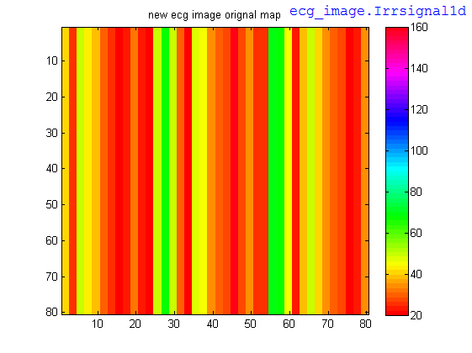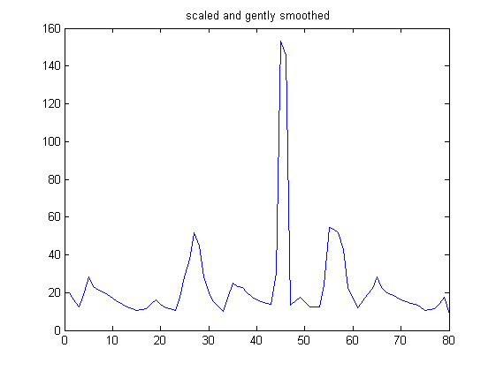

(B)

(A)

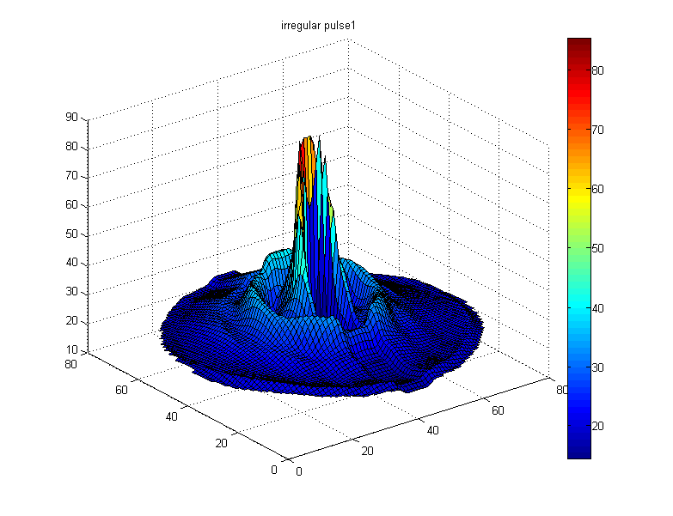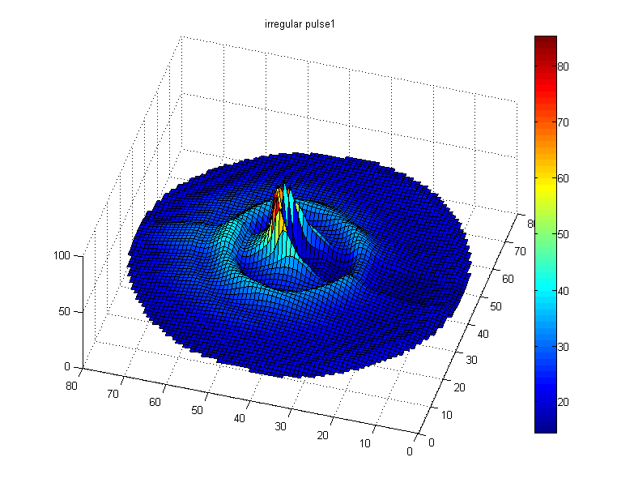

(C)

(D)

Fig 18. A normal pulse of ECG rhythm (A), ECG image of regular rhythm (B), and circular ECG map created based on ECG image in top-view (C) and front-view (D).

This is the first set of abnormal results just like in the healthy section each figure will be explained so that the result make sense to start with figure 18A is the 1D ECG that is used to create all the other figures. Figure 18B is the 2D ECG map with a clearly stated colour key this shows how healthy the heart is so in this example you can see a lot of deep reds this means that there is a lot of high amplitude in this ECG this is not good for the heart as it tells us that the heart rate is high which would alert us to certain heart conditions that have a regular high heart rate not only that the rhythm seems to be off as well as it stays high for a bit then drops down instantly then suddenly it jumps up again using the colour key it tells us that the rhythm of the heart is very irregular.

Figure 18B has been explained now figure 18C will be talked about as said before to create this figure the use of both figures A and B is needed this is a 2D circular mapping which allows us to better see the amplitude as you can see the differences between low and high amplitude more visually. As this is the first abnormal 2D circular mapping you can already see the difference between a healthy one and an abnormal one for example the waves are closer together than any of the healthy ones this could mean that the heartbeats are faster than normal causing the waves to form more closely together also in this example there is a single peak which has red, orange and yellows telling us that many types of high amplitudes are present this was the same for one of the healthy results but this peak is much higher than that telling us that the amplitudes were higher.

Figure 18D shows the robot's movement when mapped to this ECG pattern as you can see there is a small wave that contains low levels of amplitude then there is an inner wave that spikes with high levels of amplitude as the waves are formed quite close to each other this tells us that the time between the movements was fast this could be because the heart rate on this ECG was high making the movement more rapid than normal also as the wave is wider this could lead to the movements of the robot being longer.

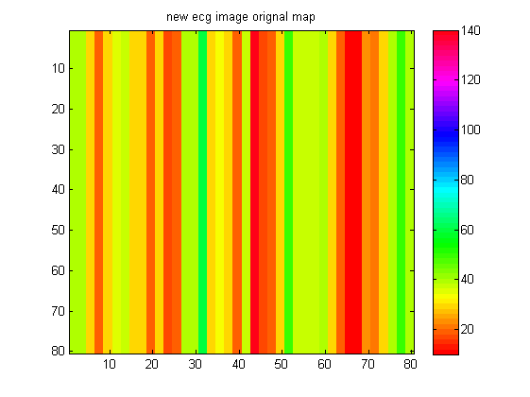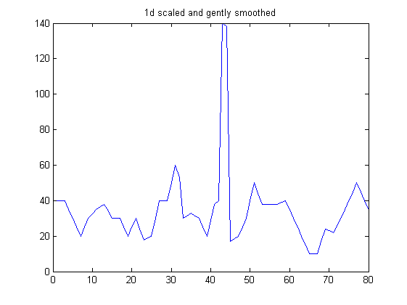

(A)

(B)

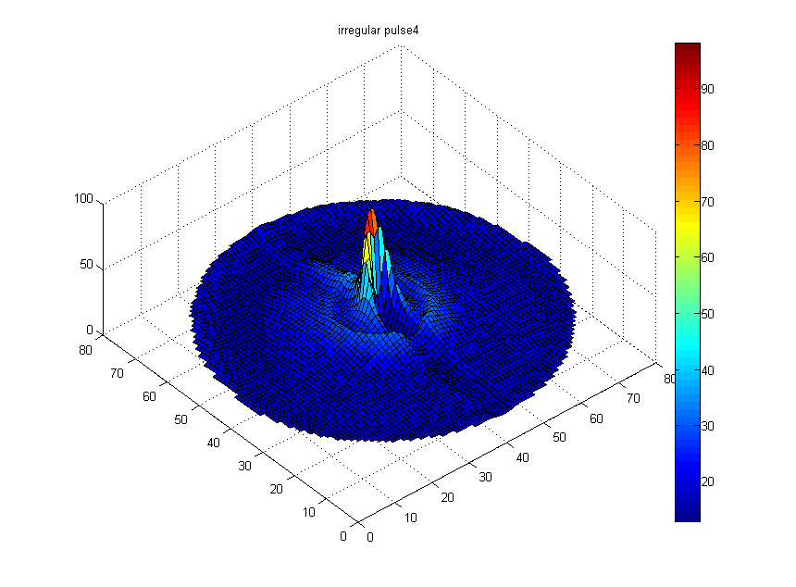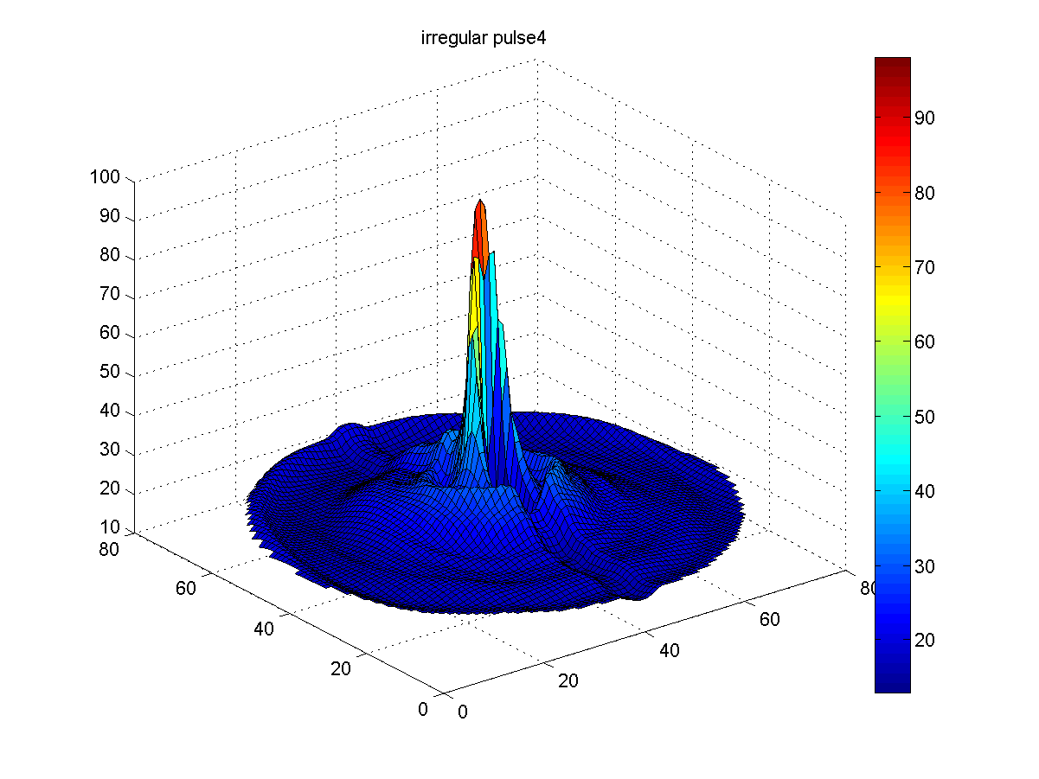

(C)

(D)

Fig 19. A normal pulse of ECG rhythm (A), ECG image of regular rhythm (B), and circular ECG map created based on ECG image in top-view (C) and front-view (D).

This is the second set of results for the abnormal section in this section figure 19B will be discussed and what that data is representing this will be the same for figures 19C and D to start this section off figure 19A which is the 1D ECG signal that has been scaled and smoothed without this result none of the others would be created.

Figure 19B is the 2D ECG colour mapping of the 1D ECG this colour mapping allows us to see at what points did high or low amplitude occur this is very important as it can show us irregular patterns or rhythms that could point towards certain heart disorders so in this example you can see that the heart is in decent shape it's not too bad as the amount of high amplitude is few compared to the amount of medium amplitude. The only problem that can be seen is that the high amplitude spikes seem to be random this is bad as it could mean that the heart is not working correctly or some section within the heart is having problems keeping up with the bodies demand.

Figure 19C is the 2D circular map that was created using both figures A and B as you can see from figure C it look similar to the first set of result in the abnormal section both waves are close to each other and the inner wave has a single spike but in this example the spike is less wide and the first wave contains less amplitude also overall the entire ECG has a lot of low amplitude readings even within the inner wave but look at the top and middle section more closely you can see more strong levels of high amplitude this tells me that when a high amplitude reading was recorded it was very high.

Figure 19D shows the robot's movement when mapped to this ECG pattern as you can see it looks very similar to the last movement there is a small wave that contains low levels of amplitude then there is an inner wave that spikes with high levels of amplitude but the difference is that the spike on this movement is higher than the last one this shows us that a higher level of amplitude was detected. Again, the waves are formed quite close to each other this tells us that the time between the movements was fast this could be because the heart rate on this ECG was high making the movement more rapid than normal.

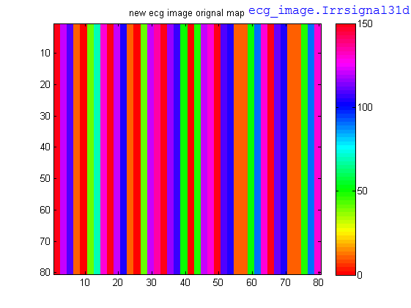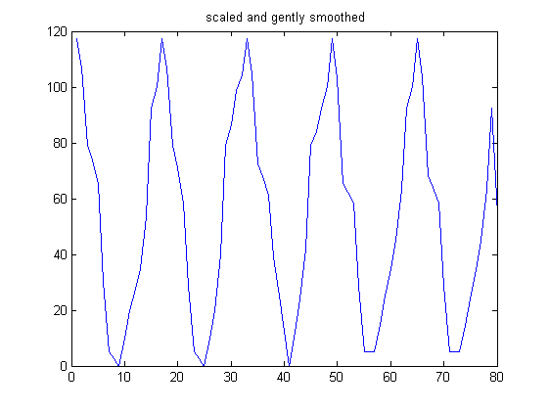

(B)

(A)

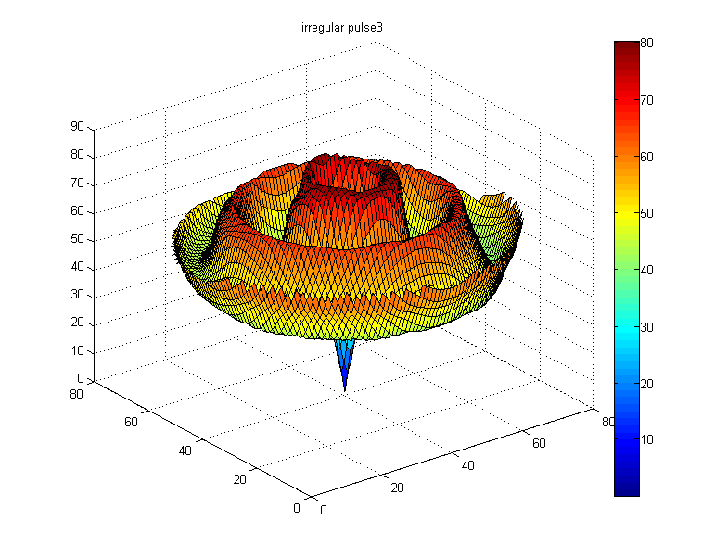

(D)

(C)

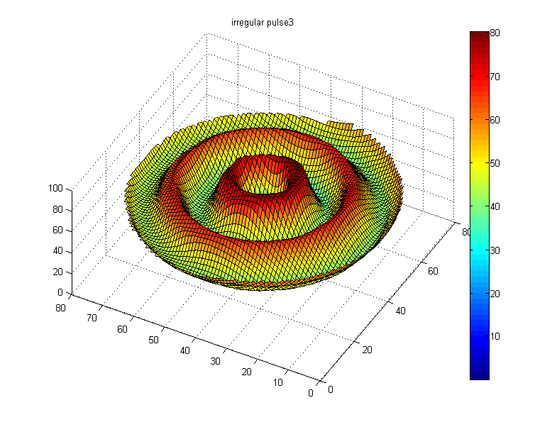

Fig 20. A normal pulse of ECG rhythm (A), ECG image of regular rhythm (B), and circular ECG map created based on ECG image in top-view (C) and front-view (D).

This is the third set of results for the abnormal section in this figure 20B will be discussed and what that data is representing this will be the same for figures 20C and D to start this section off figure 20A which is the 1D ECG signal that has been scaled and smoothed without this result none of the other results could be created.

Figure 20B is the 2D ECG colour mapping of the 1D ECG this colour mapping allows us to see at what points did high or low amplitude occur this is very important as it can show us irregular patterns or rhythms that could point towards certain heart disorders in this example you can see that the colour pattern is all over the place just by looking at the amount of different colours on the ECG you can see that this heart rate is mostly in the high amplitude section which is never good not only that but it suddenly downs to low amplitude then instantly rises again to high levels of amplitude not only that but it stays there for a long time then starts the cycle again. This heart is in very bad condition as most hearts have some high amplitude but not this much also the rhythm and heart rate of this heart would be complete off. At this point, the person has some heart disorder as no normal ECG would ever look like this by using both figure A and B as proof certain conclusion can be drawn one of these is that the heart is not healthy.

Figure 20C is the 2D circular map that was created using both figures A and B as you can see from figure C this pattern is like nothing else we've seen before even looking at the other abnormal readings you don't see anything that is even close to this. Not only is there an unusual amount of high amplitude with the lowest being light green which is shown as 40 but the way the waves are formed are unusual as this has not been seen before in any other result this would be the cause of the 1D and 2D ECG as they are both used to create this figure. One reason why the waves look like this could be that this ECG has a lot of high amplitude readings that are close together making the waves unusual if this is true then it would make sense that the waves look as they do.

Figure 20D shows the robots movement when mapped to this ECG pattern as you can see just like in figure 20C this is like nothing else we've see not only is there a very deep blue in the centre of the waves which is unusual as we've seen in the other results that the centre is normally a spike showing us the highest point but in this example, it does the opposite. A lot of high amplitude was recorded which shows that a lot of fast movement took place this would mean that the heart rate at those movements would be fast.

To conclude all the abnormal/unhealthy results just like before each of the figures prove that it is possible to program a robot's movements to an abnormal 1D and 2D ECG not only does this show the power that robots have in the medical field but it also gives us a scope of what they could do with more development which is really important to creating new and better ways to helping people.

### C:\Users\Thanapong\Desktop\health_pulse2_circularDanceMap_2dImaging_002.pngAnalytical comparison of robot movement



(B)

(A)



(C)

(D)



(F)

(E)

Fig 21. A circular 2d maps; Healthy heart (A-C), and heart disease conditions (D-F).

In this section, the robot's movements to do this each result will be compared to the rest of the results to see what is unique about that one result or how similar it is to another result. The reason why this is done is because this allows us to see what the differences are in our results and how different they are also it gives us a chance to explain our findings.

As the healthy results are list first this will be our starting point so as you can see from the healthy results there are three different robot movements each showing different ECG result but as you can see figure A and figure C are very similar when comparing the two you will be able to see that the shape of the waves are very similar. This could be because the ECG results that were used to create them were similar cases the movement to look the same or another reason could be that same levels of amplitudes were recorded this would also explain why they almost look the same. Another similarity is the levels of amplitude in the waves as you can see from the middle and top sections of the wave the readings are almost the same this is shown around the peak as you can see the colours are mostly the same.

But as you also can see they are not completely the same this is shown again in the way the waves are formed as you see not only does figure A have a higher peak but it is also narrower than figure C you can see this if you follow the peak of both movements figure A drops first while figure C continues to stay high. Another difference is that figure A isn't one whole wave like figure C you can see that figure A has a small wave before it climbs to create the other wave this isn't the case with figure C as you can see as soon as the movement starts it doesn't dip it just climbs up until it hits the peak.

In the healthy section figure B would be the odd one out it is completely different from figure A and figure C you can see this by just looking at it the first difference is that its first wave is taller than figure A and it also dips deeper unlike figure A not only that but its peak is also not as rounded as both figure A and figure C. Figure B has a centre point that contains high levels of amplitude which is different to the other two as both of them have high amplitude levels going around there peak also the amount of amplitude is different as figure B has a centre point you would normally see higher levels of amplitude but this is not the case as shown in figure A and figure C both of these have higher readings.

Now that the healthy results have been talked about the abnormal results will be talked about in this section as before robot's movement will be compared to other set of results this will show what the similarities are and the differences. The movements that are similar just like in the healthy results are figure D and figure E they are not as similar as figure A and figure C from the healthy section but out of all the abnormal results these two are the closest as you can both have a first wave that dips which then rises to the peak also before the waves are formed they both have a large amount of dark blue which shows that no or little movement was created.

These are all the similarities in figure D and figure E even if they share some traits these movements are less alike as you can see that both have very different looks the peak in figure E has higher levels of amplitude than figure D this is shown by the colour while figure D has high levels shown by orange and yellow figure E is covered in deep red which is a higher level. Another difference is that in figure D the first wave is quite big compared to figure E which the first wave is small this is shown by the amount of amplitude in these waves as you can in figure D the first wave reaches the light blue reading while figure E only stays in the dark blue levels which read as a lower level also the inner wave is very narrow compared to figure D which inner wave is wider.

In the abnormal section figure, F is completely different to any result that was collect this can be seen just by looking at all three results. Figure F waves mostly have high to very high levels of amplitude which doesn't happen in any other result not only that but the

way the waves are created is different as well in some results there is a small dip but that only happens once this happens three times and when it rises again the levels of amplitude go up this can be seen in the first dip were the top is a lighter red than the next peak which is a deeper red another big difference is that the movement suddenly drops to dark blue this is unusual as no other result does this which makes this result very unique.

Now that both healthy and abnormal have been compared to each other results now it is time to cross compare them so this will be comparing healthy and abnormal showings the main difference between the two.

Looking at both results you can see a clear difference between the two not only do the abnormal results contain more high levels of amplitude they also have the biggest difference in terms of waves. Take the two that look similar in both results you can see that figure A and figure B look more the same than figure D and figure E this shows that the waves are more stable in the healthy results this is because the ECGs in the healthy results have a more stable rhythm and heart beat causing the waves to be the same. Also, the waves in the healthy seem to be wider compared to the abnormal as in three cases in the healthy have wide peaks while only one in the abnormal results has a wide peak.

To conclude all the robot’s movements when compared to healthy and abnormal there is clear difference between the two which is what the aim was for it shows the range robots have and shows off what they can do when programmed to move to an ECG signal not only can this data be used in the medical field it proves that the robot can provide reliable data.



(A)

(B)



(D)

(C)



(F)

(E)

Fig 22. ECG imaging patterns: Healthy heart (A-C), and heart disease conditions (D-F).

In this section, the 2d ECG image mapping will be compared to do this each result will be compared to the rest of the results to see what is unique about that one result or how similar it is to another result. The reason why this is done is because this allows us to see what the differences are in our results and how different they are also it gives us a chance to explain our findings.

Just like in the last section the healthy results will be talked about first as you can see from the first three results (A, B and C) none of the results are really similar in this case the two results that are the closest will be compared in this case that would be figure A and figure C these two are the closest results in the healthy section. One of the similarities is that the amount of orange in both ECGs is quite high the reason why this could happen is that when in the 1D stage both ECG had a lot of low-level amplitude readings this would transfer over to the 2D colour mapping stage which is the result that is visible. Another similarity is that both ECGs don't have a lot of high-level amplitude readings this could be the same reason as before as the 1D ECG doesn't have many high readings it results in only a few spikes of high-level results.

The main difference between the two is that figure A has a higher amplitude reading when compared to figure C this is shown by the colour readings on the right-hand side of the figures as you can see in figure A the max reading is 140 while in figure C the max is 120 using these max results a clear difference can be seen as figure A has higher amplitude levels than figure C this also means that figure A has more potential to have high-level reading as it has a higher level of amplitude. Another difference is that figure C has a lot more low-level amplitude reading overall when compared to figure A this tells us that figure C overall has a lower level amplitude reading.

Figure B is unlike the others in many ways you could say that it is the odd one out in these results as when compared to the other two it has no similarity as shown by the colours and the way they have charted on this map. Firstly, you can see that in figure B levels of high amplitude are present more often than in both figure A and figure C not only that but in figure B a clear pattern can be seen this pattern is as followed high amplitude then a few sets of low amplitude then high again this is the pattern in figure B which can be seen unlike with figure A and figure C were the pattern is harder to see. Another difference that can be seen when compared to figure A and figure C is that the low readings stay the same throughout the whole ECG unlike figure A and figure C were the low-level readings move up and down a lot this could be because the 1D ECG that was used in figure B was more stable than both figure A and figure C.

Now that the healthy results have been talked about the abnormal results will be talked about in this section as before the 2D colour mapping is going to be compared to other set of results this will show what the similarities are and the differences. Just like in the healthy results the two results that are similar to each other will be compared as you can see none of the results look similar in any way so the two results that are closest to each other this would be figure D and figure E as said before these two results don't have anything in common so the main focus will be on the differences between the two. One of the main differences is that figure D has many high readings compared to figure E as you can see figure D has deep red almost throughout the whole ECG while figure E has a few high spikes this could be because the 1D ECG had a lot of high amplitude spikes this would explain why the 2D ECG colour mapping looks as it does.

Another difference is that figure D has more higher levels of amplitude this is shown by the colour readings on the right-hand side of the figure as you can see figure D has a max reading of 160 while in figure E the max reading is 140 this shows us that figure D has a higher level of amplitude reading than figure E. Another difference is that figure E has a lot lower to medium readings compared to figure D this would be because the 1D ECG in figure E had more low to medium level readings causing the 2D ECG mapping to show what you see.

Figure F would be the odd one out in the abnormal results this is because compared to the other two it shares no similarities this is shown best by the number of colours in the ECG as you can see figure F has a very different array of colours compared to figure D and figure E this shows us that the rhythm is very different in all three readings. looking at this colour scheme you can see that the ECG rhythm is all over the place from the very start its high as it continues on it lowers a bit then drops suddenly after that it quickly picks up then switches from high to low very quickly this is very bad as from this reading what can be said is that the heart is in very bad condition as most of the readings are in the high levels.

To conclude all the 2D ECG colour mapping when compared to healthy and abnormal a clear difference between the two which is what the aim was for this shows the different ranges that can be given to the robot as in these results both ranges are tested one is really healthy while the other set is really abnormal using both of these results proof’s that the robot is powerful in all ranges.

There are some limitations in our study that should be addressed. Firstly, as the study didn’t have any participants it is hard to understand the relationship between this robot and the user this would create problems if this study was to be tested in the field as it could affect the results. In many cases involving robots the person that was working with the robot had felt some discomfort or unease this could cause higher levels of amplitude as the person is under stress which is known to cause the heart to beat faster. Secondly, in our ECG reading there is only one problem or one condition that is being looked at this would not be the case in many ECGs as a person could have more than one heart condition at one time trying to program the robot to match the dance pattern of both could create some difficulty. Thirdly, the budget of this study would have to be increased as it stands one robot costs $499 convert that to pounds and it totals £389.33 which isn’t cheap if this study was to be used in hospitalises across the UK it would be imperative to find a cost-efficient way to mass produce these robot as at the moment it could not be done as it would require a lot of funding. Finally, the robot itself is a limitation this robot is fine for this scale of study as it doesn’t require too much complex ECG readings which means that complex movement is less involved but if the study grew then the amount of complex movement would increase as well and at that point this robot would become inefficient as it would lack the degree of freedom needed to do complex movement this also would impact the budget of the study as well as the more sophisticated the robot is the more it will cost so this requires a balance of sophistication and cost efficiency.

To conclude the limitations of this study as a small-scale study there are no problem but when the study grows the problems become more visible from the cost of the robots to the amount of time needed to program them these are key factors that will hold this study back if a way is found were the cost of the robots can drop and the time needed is shorted then this study has a real future as it works well given the results that have come from our tests.

## Conclusion and Ongoing Work

This paper set out to prove that a robot could be programmed to dance to an ECG signal to provide accurate data which could be used to characterize heart conditions not only would this show the abilities that robots have in the medical field but it would also show that robots can be used in different areas within the medical field. While collecting our research, certain factors were expected to happen the first would be that the robot could dance to any ECG signal and the second was that the robot was clear in the message that it was presenting these two ideas were some of the expectations from this project. Given the results that have been collected shows that it is possible to program a robot that dances to an ECG signal which gives us accurate data which could be used to characterize heart conditions.

This study has shown me that robotics is a field that is always changing with new technologies and situations that challenge us to create robots that fit into every environment possible with this said most of this study has and is done outside of Europe this is an opportunity missed as the benefits of this study are great and can be applied to any field. The reason why this study is important is because it has limitless possibilities it can be used everywhere and anywhere with the right development robotics is the next big technological breakthrough that will open many doors and advance studies to reach newer highest.

As stated before robotics is every changing and is limitless but a few ongoing works that could become possibility in the near future is the introduction of robotic nurses and robotic shop assistants these might be small steps but it will allow people to get a better understanding of robots and allow them to see that they are useful to us. In terms of this project if more time was available then more testing of the different ranges would be done this would test to see how complex the robots is this also more time collecting more complex signals to see how differently the robot movements are. Not only that but trials would be a request that would allow me to set up at local GPs and child hospitals were the robots would be on display and used in ECG procedures and interview how the person felt when interacting with the robot this would allow me to better understand the views of the users.

## References

Anas, M., Norali, A. and Jun, W. (2014). On-line Monitoring and Analysis of Bioelectrical Signals. *Procedia Computer Science*, [online] 42, pp.365-371. Available at: http://www.sciencedirect.com/science/article/pii/S1877050914015130 [Accessed 9 Dec. 2016].

Bien, Z. and Lee, H. (2007). Effective learning system techniques for human–robot interaction in service environment. *Knowledge-Based Systems*, [online] 20(5), pp.439-456. Available at: http://www.sciencedirect.com/science/article/pii/S0950705107000135 [Accessed 9 Dec. 2016].

Cadogan, M. (n.d.). *ECG electrode system*. [image] Available at: https://lifeinthefastlane.com/ecg-library/basics/lead-positioning/ [Accessed 3 Jan. 2017].

Cadogan, M. (n.d.). *Waves of the ECG*. [image] Available at: https://lifeinthefastlane.com/ecg-library/basics/p-wave/ [Accessed 3 Jan. 2017].

DailyCare BioMedical Inc. (2017). Introductory guide to identifying ECG irregularities,   
 Taoyuan, Taiwan. Available at: www.dcbiomed.com [Accessed 10 Jan 2016].

Gould, A. (2011). *How the heart creates a beat and the different heartbeats*. [image] Available at: http://galura-basa.blogspot.co.uk/2011/06/normal-and-abnormal-ecg-readings.html [Accessed 3 Jan. 2017].

Isa, S., Noviyanto, A., Jatmiko, W. and Arymurthy, A. (2012). The Effect of Electrocardiogram Signal Compression Using Beat Reordering and SPIHT on Automatic Sleep Stage Classification. *Procedia Engineering*, [online] 41, pp.888-896. Available at: http://www.sciencedirect.com/science/article/pii/S1877705812026598 [Accessed 9 Dec. 2016].

NixonMcInnes (2013). *Atrial Fibrillation*. [image] Available at: http://www.ambulancetechnicianstudy.co.uk/rhythms.html#.WPXgSWnyuUl [Accessed 4 Feb. 2017].

NixonMcInnes (2013). *Sinus Bradycardia*. [image] Available at: http://www.ambulancetechnicianstudy.co.uk/rhythms.html#.WPXgSWnyuUl [Accessed 5 Feb. 2017].

Sauppé, A. and Mutlu, B., 2014, April. Design patterns for exploring and prototyping human-robot interactions. In Proceedings of the 32nd annual ACM conference on Human factors in computing systems (pp. 1439-1448). ACM. [Accessed 9 Dec. 2016].

Wehner, S. and Bennewitz, M., 2009. Optimizing the Gait of a Humanoid Robot Towards Human-like Walking. In ECMR (pp. 277-282). [Accessed 9 Dec. 2016].

Zanchettin, A., Bascetta, L. and Rocco, P. (2013). Acceptability of robotic manipulators in shared working environments through human-like redundancy resolution. *Applied Ergonomics*, [online] 44(6), pp.982-989. Available at: http://www.sciencedirect.com/science/article/pii/S0003687013000707 [Accessed 9 Dec. 2016].

“Every reasonable effort has been made to acknowledge the owners of copyright material. I would be pleased to hear from any copyright owner who has been omitted or incorrectly acknowledged.”

**Signature:**

**\_\_\_\_\_\_\_\_\_\_\_\_\_\_\_\_\_\_\_\_\_\_\_\_\_**

**Daniel D. McHugh** April 2017

## Appendix

|  |  |
| --- | --- |
| **Liverpool Hope University**    **Ethical Approval Request only for research involving human participants  who are NOT children (below 18) or vulnerable adults**   1. For text-based projects not involving human participants, use the designated shorter request form rather than this one. 2. For projects involving children or vulnerable adult, use the designated longer request form rather than this one. | |
| ***SECTION 1*** *[TO BE COMPLETED BY THE RESEARCHER]* | |
| **1.1 Researcher**  **For staff: Name:**  **(For joint research conducted by staff, the names of all the researchers should be given with the Principal Researcher’s name given in bold.)**  **For students: Name, student ID, name of supervisor:** | Daniel McHugh, ID 13005235  Dr. Thanapong Chaichana |
|  | |
| **1.2 Title of Proposed Project:** | Robotic dances to characterise heart conditions |
|  | |
| **1.3 For students only: Programme Title and Level of Study (e.g. MA Education; Philosophy and Ethics Level H)**. | Computer Science  Level H |
|  | |
| **1.4 For staff only: Position held at Hope (e.g. Lecturer)**. |  |
|  | |
| **1.5 Faculty and Department or equivalent :**  (*for research involving two Faculties* *or Departments, please state both. The name first given should be that of the Faculty and Department whose DEL is being asked to approve*.[[1]](#footnote-1)) | Department of Mathematics and Computer Science |
|  | |
| **1.6 Start date of proposed research**  (note: this must be later than the date at which approval may be given)  **End date of proposed research** | April, the 21st, 2017 |
| May, the 31st, 2017 |
| **1.7 Professional guidelines referenced** | Yes |

**SECTION 2**

**NOTES ON ALL RESEARCH INVOLVING HUMAN PARTICIPANTS**

**Approval** will be given by

1. The University Research Ethics Sub-committee for

* research that may involve deceptive or covert activity
* empirical research into illegal activities
* research that may be connected to any aspect of national security
* and/or research deemed to pose a significant risk to the University’s reputation.

The researcher should identify all such cases and refer them to their supervisor, who in turn will contact their Departmental Research Ethics Lead (DEL) for suggestions. The DEL will forward the application to the Faculty Research Ethics Sub-committee for consideration and, if necessary, for referral to the University Research Ethics Sub-committee

OR

1. The Faculty Research Ethics Sub-committee for research involving children (under 18) or vulnerable adults and recommended by a Departmental Research Ethics Lead (DEL)

OR

1. The DEL for research involving human participants but NOT children (under 18) or vulnerable adults.

OR

1. An authorized staff who for good reason cannot refer the request to a supervisor

NOTE: For projects not involving human participants, use the designated shorter request form rather than this one.

In all cases, initial scrutiny will be carried out by the supervisor or DEL, as appropriate.

Initial scrutiny consists of a careful reading of the request coupled with ensuring completion of the checklist given at the end of this form. This process may need to be iterative with the researcher\*. When ALL responses are satisfactory, the initial scrutineer should complete the last section of the checklist and should send this form (and any associated documentation) on to the next stage of the process as explained at the end of the checklist.

\*If ANY prompt cannot be given an acceptable response, the initial scrutineer should return the form to the researcher, clearly explaining the remedial action needed, and advising of a deadline for the form to be returned to the initial scrutineer.

Section 3. INFORMATION ABOUT PROPOSED RESEARCH STUDY.

Note: the checklist given at the end of this document should be completed by the researcher. The initial scrutineer may either add to it, or simply endorse it as agreed. A supervisor or DEL receiving a form without the checklist having been completed will return it to the supervisor (for student research) or the researcher (for staff research) for completion.

|  |
| --- |
| **3.1 GENERAL** |
| **a)** Full title of the research project:  Robotic dances to characterise heart conditions |
| **b)** Aims and objectives:  1) To identify healthy and irregular heart conditions using ECG open-access  databases via online Internet  2) To visualise the heart conditions using the robots  3) To program the moment of the robots by following the ECG patterns |
| **c)** Brief outline of the research study. Please ensure that you include details of the **design** (qualitative/quantitative, etc) as well as the **methods and procedures** (questionnaire, interviews, experimental trial, observation, etc).  **A summary of research project**  Heart disease is a leading cause of death worldwide. The prevention and early diagnosis of heart failure usually required to visualise the heart conditions. In  clinical, the risk assessments of heart conditions included the blood tests, a chest  X-ray, and Electrocardiogram (ECG) analysis. ECG visualisation is non-invasive technique to diagnose heart conditions. The classifications of healthy and  unhealthy conditions were stated upon the online open-access ECG databases via  Internet. This study analysed the conditions of the heart thought the movement of robots using ECG data. The robots were programmed the movement based upon healthy and irregular ECG patterns. Results demonstrated the robot dances clearly characterise the normal and abnormal heart rhythms. Therefore, the humanoid robot was successfully programmed its movements based upon the heart rhythms.  **A summary of research design**  The research project was designed to using the open-access ECG databases via  Internet. The diagnosis of heart conditions has been done prior creation of the internet database, and already stated the conditions of heart rhythms in both healthy and irregular ECG signals. A robot manoeuvre itself will be used randomly  Research Ethics Application Form - Research with NON-vulnerable human groups from both healthy and unhealthy ECG signals to visualise the heart conditions.  Thus, the robot will be moved differently using ECG signals of both normal and abnormal heart conditions.  **A summary of research methods and procedures**  The research project was planned and approached as following steps: 1) collection  of ECG signals on the Internet from open-access databases; 2) classification of  healthy and unhealthy ECG signals that have been analysed and shown in open-  access databases; 3) creation of the ECG patterns using Matlab 2017b; 4)  Program the movement of robots by following the ECG patterns; 5) Visualisations of normal and abnormal heart conditions through the robot movements. |
| **d)** As mentioned under Section 2 (a), some types of research must be referred (by the Faculty Ethics Research Sub-Committee) to the University Research Ethics Sub-Committee. Therefore, please state here if your research involves or may involve deception, the use of covert methods, is into matters involving national security, is into illegal activity or might endanger the University’s reputation. Please also highlight the key aspects which cause it to fall into one or more of these categories.  According to the research design, methodology and procedure, this research project was used the open-access ECG databases, and this work was truly original work. This project did not fall into any subcategories as mentioned under Section 2  (a). Thus, this research clearly not involved in any deception, aspect of national security, illegal activities, and a significant risk to the University’s reputation. |
| **e)** Where will the study take place and in what setting? If in a workplace, or if the participants are from a workplace, identify what your connections are with that workplace.  The proposed research project will be mainly conducted at the 4th floor FML  Building in the rooms: FML415, FML413 and FML412 within the Liverpool Hope  University Hope Park Campus, Liverpool, United Kingdom. There will be no setting rooms for conducting experiments in any rooms as stated above previously.  Additionally, there was no participants in this research project from the Liverpool Hope University and outside the Liverpool Hope University. |
| **f)** Give a brief description of your target sample (e.g. age, occupation, gender).  There has not been designed to setup any targets of any samples according to the age, occupation, gender, nationality, and or any issues that will cause diversity cultures. It has clearly stated the random of ECG signals in both healthy and unhealthy conditions will be randomly collected from open-access databases. |
| **g)** Is the participation individual or as part of a group?  Since, this research project was not directly involved to take any sample subjects; ECG data were randomly chosen from oven-access databases, as well as, there was not target sample in this wok. Thus, there were no any ethical issues involving the individual and group participants in this study. |
| **h)** How will participants be selected, approached and recruited?  Clearly identify and fully analyse any issues of power relations that might arise, and say what steps will be taken to alleviate them. This applies particularly if the location of the research is a place of the researcher’s employment, or if they have other strong links with the participants.  The ECG signals that were used to drive the robot movements have been randomly chosen from oven-access databases in both normal and abnormal heart rhythms. |
| **i)** Free and informed consent and the right to withdraw at any time are indispensable.  NO, this study was no actual participants, and this resulted to be free from the consent and the right to withdraw this study at any time. The research designed to use the human data from open-access online Internet databases. Thus, it is freely to use, and has the right to use, and it is already anonymous data.  How will the participants’ right to withdraw be ensured?  None. |

|  |
| --- |
| **3.2 Risk & Ethical Procedures**  Please note: all studies with human participants have the potential to create a level of risk. “No risk” is thus not an acceptable answer, although “Minimal risk” is. You are fully responsible for the protection of both yourself and your research participants. Please try to anticipate the context and perspective of your participants when completing this section. |
| **a)** What potential risks are there of physical harm to participants? Please specify, and explain any steps you will take to address them.  This study was declared as the Minimal risk related to the Risk & Ethical Procedures. There will be no chance to physical harm the researchers (declared as supervisees) and their supervisors. Since, the research design, methods and procedures were not involved to conduct the research using any equipment and tools contacting and touching the users’ skin and body. |
| **b)** What potential risks are there of psychological harm to participants? In particular, how might participation in this research cause discomfort or distress to participants? Please specify, and explain any steps you will take to address these issues.  This study was declared as the Minimal risk related to the Risk &amp; Ethical Procedures. There will be no chance to psychological harm the researchers (declared as supervisees) and their supervisors. Since, the research design, methods and procedures were not involved to conduct the research in any setting rooms and experimental conditions associated to the change of mindset, environmental factors, and the way of thinking to the society within Liverpool Hope University. |
| **c)** Are there any risks to you as the researcher (and / or your co-researchers, if you have any) in this project? If so, outline the steps you will take to minimise them.  This study was declared as the Minimal risk related to the Risk &amp; Ethical Procedures. There might be the body fall onto the ground while holding the robots. Solution: Try not the hold all robots together during programming, and move them to the storeroom. |
| **d)** How might participants benefit from taking part in this research?  No, there is no any beneficial. Since, there were no actual participants in this study. |
| **e)** Does any aspect of your research require that participants be naïve *(i.e. they are not given full or exact information about the aims of the research)*? Please explain why and give details of the debriefing procedures you would use when the need for the naiveté is over.  No, there is no any expectation to be expected from the random of the study samples. Since, there were no actual participants in this study. |
| * 1. **Data Security, Confidentiality, Anonymity and Destruction** |
| **a)** Where and how do you intend to store any data collected from this research? Give details of steps you will take to ensure the **security** of any data you collect.  Note that data protection regulations stipulate that data must be stored securely and not be accessible or interpretable by individuals outside of the project. Hence, data should be stored in a password-protected file on a password-protected device such as a desktop or laptop, and not on easily movable devices such as USB keys or CD ROMs.  The codes of ECG programming and robot programming with all files and information will be stored into the CD ROM encrypted passwords. All results and codes were also saved into the CD ROM. The total of three original CD ROMs will be provided to the departments with the supervisor (Dr Thanapong Chaichana), co-supervisors/mentors (Dr David Reed and Dr Mark Barrett-Baxendale). |
| **b)** What steps will you take to safeguard the **confidentiality and anonymity** of personal records?  Nothing, there were no actual participants in this study. |
| **c)** Will this research require the use of any of the following (please delete as appropriate):   |  |  | | --- | --- | | Video recordings | NO | | Audio recordings | NO | | Photos | NO | | Observation of participants | NO |   If you answered YES to any of the above, please provide a more detailed explanation of how you will ensure confidentiality and anonymity.  Another part of this study is to research how people view robots this will help when designing and building the robot |
| **d)** Please confirm that you will destroy all personal data and indicate at which point you will do so.  **For students**: A date should be provided.This should normally be no later than the end of their degree programme. Students should NOT make this point dependent on a successful outcome of their studies.  I confirmed that the data produced from this research project were removed all  essential information related to researcher, supervisor, any person, samples involved in this study and Liverpool Hope University in term of rule and regulation.  Thus, I confirmed that this research project generated the data anonymisation from  April, the 21st, 2017.  **For staff**: A date should be provided. For certain types of research, it is acceptable for destruction of anonymised data to be indefinitely deferred. This must be clearly declared in the Research Information Sheet.  I confirmed that this research project generated the data anonymisation from April, the 21st, 2017. |

|  |
| --- |
| **4 For students only: Supervisor’s comments** |
| **(**Please note that applications submitted without supervisor’s comments will not be considered.)  I confirmed that Mr Daniel McHugh’ statement is genuine, and he have done this research project upon the visualisation of heart conditions through robotic movements.  **Supervisor’s name:** Dr Thanapong Chaichana  **Date:** April, 21st,2017 |

**Blank Research Consent Form and Research Information Sheets are appended. Please ensure you complete the relevant forms, and delete any that are not required.**

**Note 1**

The question of when childhood is deemed to end, such that mentally capable young people can themselves give free and informed consent without needing parental consent, is much discussed, and to some extent depends on the reason why the consent is being sought. As a precaution the University takes the age of personal consent for research participation as being 18, and this should be applied throughout. Only if ALL participants in this research are over 18 should this form be used.

****

**LIVERPOOL HOPE UNIVERSITY**

**RESEARCH CONSENT FORM**

**Title of research project:** Robotic dances to characterise heart conditions

**Name of researcher:** Daniel McHugh

|  |  |  |
| --- | --- | --- |
| 1. I confirm that I have read and understand the information sheet   for the above research project and have had the opportunity to ask questions. | Yes | No |

|  |  |  |
| --- | --- | --- |
| 2. I understand that my participation is voluntary and that I am free to withdraw at any time, without giving any reason. | Yes | No |

|  |  |  |
| --- | --- | --- |
| 3. I agree to take part in this research project and for the anonymised  data to be used as the researcher sees fit, including publication. | Yes | No |

Name of participant: No participant

Signature: Daniel McHugh

Date: April, 21st, 2017

****

**LIVERPOOL HOPE UNIVERSITY**

**RESEARCH INFORMATION SHEET**

**Outline of the research** (a couple of sentences in non-specialist language):

**Who is the researcher?**

Name: Daniel McHugh

Institution: Liverpool Hope University

Researcher’s University email address: 13005235@hope.ac.uk

**What will my participation in the research involve?**

None

**Will there be any benefits to me to taking part?**

None

**Will there be any risks to me in taking part?**

None

**What happens if I decide that I don’t want to take part during the actual research study, or decide that the information given should not be used?**

No, this research has never used any information from the participants.

**How will you ensure that my contribution is anonymous?**

This research has used anonymous data.

**Please note that your confidentiality and anonymity cannot be assured if, during the research, it comes to light that you are involved in illegal or harmful behaviors that I may need to disclose to the appropriate authorities.**

Yes, I am confident that I have used and produced anonymous data within my research project.

****

**CHECKLIST FOR RESEARCH ETHICS APPROVAL REQUESTS**

**(STAFF OR STUDENT)**

**Name of researcher: Daniel McHugh**

**Name of Supervisor (if student):** DrThanapongChaichana

**Date completed:** April, 21st, 2017

|  |
| --- |
| **For use by staff or students to help improve the Ethics Approval request before submission**  **For use by supervisors before completing the Supervisor comments section of the form. If you cannot answer ‘Yes’ to every prompt, please discuss with, or return the form to, the student.** |

**Checklist completed by:** Daniel McHugh

**Date:** April, 21st, 2017

|  |  |  |
| --- | --- | --- |
| **PROMPT** | **See form:** | **Yes/ No** |
| * + 1 Start-date is after date of scrutiny | 1.6 | Yes |
| * + 2 Appropriate professional guidelines are identified | 1.7 | Yes |
| * + 3 Informed consent is being sought from ALL relevant parties and Consent Form(s) and Research Information Sheet(s) are included. | 3.1.i, end of document – Research Information Sheet(s) and Consent Forms. Check that they match. | Yes |
| * + 4 Power relations are clearly defined and discussed and appropriate steps to address any issues are set out | 3.1 e and 3.1. h | Yes |

|  |  |  |
| --- | --- | --- |
| * + 5 Risk to research subjects is adequately discussed and addressed. ‘No risk’ is not an acceptable response, although ‘minimal’ is. *Note that if questionnaires or interviews are involved, part of the assessment of risk is linked to the questions to be asked. It is therefore helpful if these can be attached, or at least if there can be as full information about them as possible.* | 3.2 a–c | Yes |
| * + 6 Risk to the researcher is adequately discussed and addressed | 3.2 d | Yes |
| * + 7 The right to withdraw is explicit and fully thought through in this Request Form. The Inform Consent Forms the Research Information Sheet(s) contain further information. It might be necessary for the researcher to give quite detailed information about HOW participants can withdraw and how possible psychological harm could be avoided. | Often discussed under 3.1 i | Yes |
| * + 8 Anonymity is adequately dealt with in the Request Form and is confirmed in the Research Information Sheet(s) | 3.3 | Yes |
| * + 9 Confidentiality is adequately dealt with in the Request Form and is confirmed in the Research Information Sheet(s) | 3.2 b | Yes |
| * + 10 Security of information is adequately dealt with in the Consent Form and is confirmed in the Research Information Sheet(s) | 3.3 a | Yes |
| * + 11 Destruction of information is adequately dealt with in the Request Form and Research Information Sheet(s)   + For students: destruction of the data should not be be made dependent on **successful** completion of the research project. An expression such as ‘when my studies are complete’ covers all eventualities.   For staff: it is acceptable for staff research to have a ‘never destroyed’ statement, but this must be transparent in the Research Information Sheet(s) and Consent Form(s). | 3.3 d | Yes |
| * + 12 The research is NOT into illegal activities | 2.a & 3.1. d  Likely to be buried in the narrative | Yes |
| * + 13 The research does NOT employ deceptive or covert methods, such as to negate or impede the ability of the participants to give informed consent. | 2.a & 3.1. d  Likely to be buried in the narrative | Yes |
| * + 14 The research HAS NO interaction with issues of national security | 2.a & 3.1. d | Yes |

Note that if any of the last three prompts indicates that the problem scenario is present, the request will not necessarily be refused, but it will need to be sent (by the Faculty Sub-committee) to the University Sub-committee. Please flag this up when sending the form to the Faculty Sub-committee, but it would be helpful if you also completed the rest of the checklist.

**APPROVAL**

**Please select A or B, as appropriate. Delete the other.**

**A: For STUDENT RESEARCH – to be completed by the DEL:**

I APPROVE the research and it may begin immediately. Any improvements listed below (or as communicated – please make clear) should be made and incorporated in your completed work.

**Name:** Dr Emanuele Lindo Secco

**Role** (i.e. supervisor or a different DEL acting in lieu of supervisor): DEL

**Date** (must be earlier than proposed start date): April, 21st, 2017

1. The University does not require double approval for shared research. Where the research is Cross-Faculty, the researcher should seek advice from an appropriate person about which Faculty should be asked to approve.

   [↑](#footnote-ref-1)